Name:________________________________

Chapter 5- Forces Regents Physics


Newton’s Three Laws of Motion

Newton’s First Law (Law of Inertia)

- Objects at rest will remain at rest unless acted upon by an unbalanced force. Objects in motion will remain in motion unless acted by an unbalanced force.

- An unbalanced force is a nonzero net force acting on an object.

- The law of inertia is another name for the first law. Inertia is the resistance of an object to a change in its motion.

- THE INERTIA OF AN OBJECT IS DIRECTLY PROPORTIONAL ONLY TO ITS MASS!!!
(The fundamental SI unit of mass is the kilogram “kg”)

For Example:

- Which object has more inertia: A 1,200-kg object moving at 10 m/s or a 500-kg object moving at 40,000 m/s? (Only dependent on mass!)

Newton’s Second Law (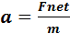)

- According to Newton’s second law, when an unbalanced force acts on an object, the object is accelerated in the same direction as the force. The acceleration is directly proportional to the magnitude of the unbalanced force and inversely proportional to the mass of the object or:

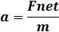

- Net force means you must find the unbalanced force acting on an object.

For Example:

- Alexa pushes on an object with 10 Newtons of force to the right. Julie pushes the same object with 6 Newtons to the left. What is the net force acting on the object? (This is why we did vectors!!!)

- The unit for force is one Newton. A Newton is equivalent to a kg.m/s². This can easily be derived since F_{net}= ma. Since mass is in kilograms and acceleration is in m/s², then force is in kg.m/s² or a Newton.

For Example:

- Nick pushes a refrigerator with 100 Newtons of force to the right while Ryan pushes with 60 Newtons to the left. If the refrigerator is 100 kg, determine the magnitude and direction of the refrigerator’s acceleration. (Use our new formula and make sure to find net force!)

- Many instances will require a free-body diagram which is a sketch, or scale drawing, that shows all forces acting concurrently on an object. Draw a box to represent the object and use vectors (with arrowheads) to represent the forces.

- Draw a free-body diagram for the situation in Example 3.

- Celeste pushes a 5.0 kg Thanksgiving Food Drive box across the stage. If the box moves across the stage with an acceleration of 3 m/s², determine the net force applied by Celeste.




- A force of 10 N is applied to an object which accelerates it at 2 m/s² to the right. If there is 4 N of friction to the left, determine the mass of the object.
Include a free-body diagram.
- The Regents will also want you to know how to interpret various graphs involving Newton’s Second Law. Let’s determine how these graphs look.

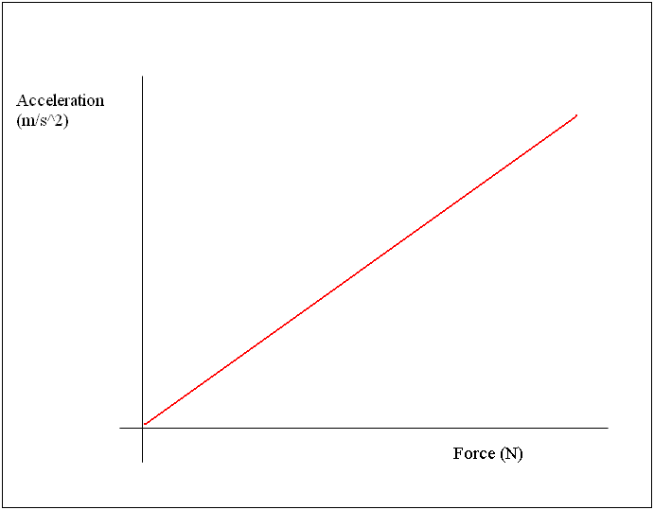
Since a = , as Force increases, acceleration increases with a direct proportion.

What does the slope of this graph represent?

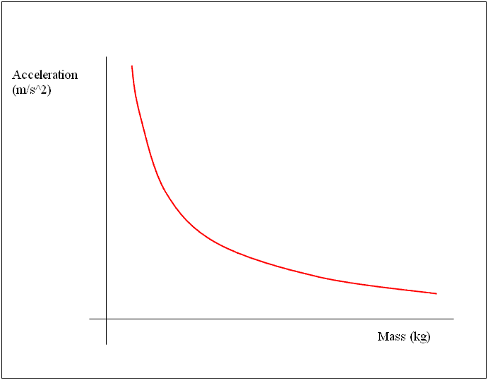

Furthermore, as mass increases, the object will be harder to accelerate. Therefore, as mass increases, acceleration decreases.

This is known as an inversely proportional graph.

Newton’s Third Law (Action-Reaction)

- According to Newton’s third law, when one object exerts a force on a second object, the second object exerts a force on the first that is equal in magnitude and opposite in direction. In other words, for every action force, there is an equal and opposite reaction force.

For Example:

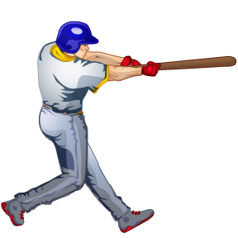
- A bat exerts a 50-Newton force on a baseball. How much force does the ball exert on the bat?

- A girl weighing 600 Newtons pushes a car with a weight of 5,000 Newtons with a force of 100 Newtons. How much force does the car exert on the girl?

