Name:________________________________

Chapter 5- Forces Regents Physics

Special Topics in Forces

- Elevators
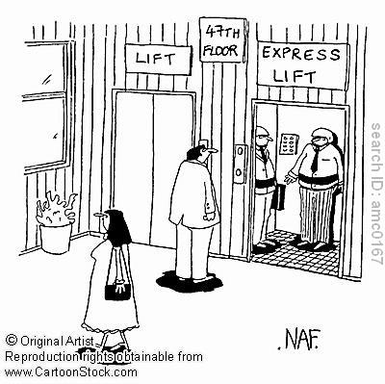
There are four situations on an elevator that the Regents wants you to know: at rest, moving with constant velocity, accelerating upwards, and accelerating downwards. In each of these problems, they will place an object or person on a weight scale in an elevator.

- At Rest:

If a person is standing on a bathroom scale inside an elevator, the scale will read the NORMAL FORCE applied to the person by the scale. Therefore, if the elevator is at rest, the bathroom scale will simply read the person’s weight.

Example:

- Alex enters an elevator and walks on to a scale while the elevator is at rest.

  - What is the net force acting on Alex?

  - If Alex weighs 700 Newtons, what will the scale read?

- Moving with Constant Velocity

If an elevator moves with constant velocity, the acceleration is 0 m/s², thus the net force acting on a person is zero (F_{net} = ma). This is similar to the elevator being at rest.

- Erin is on her way to the 50th floor of the Empire State building in an elevator. If she rises at a constant speed and she weighs 500 Newtons:

  - What is the net force acting on Erin?

  - What will the scale read?

- Accelerating Upwards

How do you feel when an elevator accelerates upwards?

When an elevator accelerates upwards, the floor of the elevator pushes harder against your body. Thus you will feel heavier. Furthermore, the bathroom scale will read a normal force that is greater than your weight (since the scale has to provide a stronger force to push you upwards).

- Joe pushes an elevator button to accelerate him upwards to the 44th floor. If Joe weighs 600 Newtons, what will the scale read?

- Accelerating Downwards

How do you feel when an elevator accelerates downwards?

When an elevator accelerates downwards, the floor of the elevator has to push less against your body. Thus you will feel lighter. Furthermore, the scale will read a normal force that is less than your weight.

- Jack weighs 700 Newtons. If Jack is accelerating downwards in an elevator, what will be the reading on the scale?

Note: In fact, if the cable breaks (let’s hope not!) the person will feel be in free-fall and feel weightless. The scale reading will be zero!

The Regents rarely asks for elevator calculations but here is how to do them:

- Brian walks into an elevator and stands on a scale. If Brian has a mass of 80 kg and the elevator accelerates upwards at 3 m/s², determine the reading on the scale.

- Forces at an Angle

Recall that when we calculate net force, we have to work in one direction at a time. But what happens when a force is applied at an angle? We must componentize the force in order to make our calculations. Most of our problems will work in the horizontal direction (x-direction) so we will be using cos θ.

For example:

6.)

Anthony pulls a 15-kg box out from under his bed with a force of 40 Newtons at an angle of 40 degrees to the horizontal.

    - Complete the FBD above.

    - Determine the horizontal component of the force pulling the box.

    - If there is a frictional force of 10 Newtons, determine the acceleration of the box. (Make sure to use the applied horizontal force in part A!)

    - Will the normal force be more or less than the weight of the box? Why?

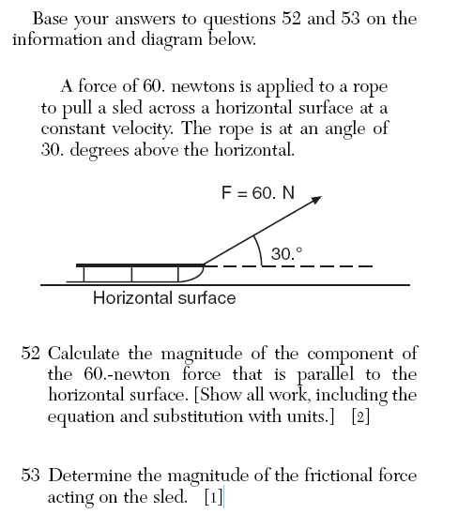

- Forces on a Hill

We have already discussed that the normal force will always be perpendicular to the surface of the hill and that weight is always straight down.

Show these forces:

Now let’s focus on how to calculate the force causing the block to slide and the normal force.
- On a hill, the force pulling the object down is the component of weight that is parallel to the hill as show below. This is calculated by:

mg sin θ

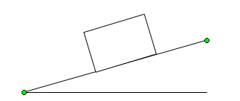
Where θ is the angle between the ground and the hill.

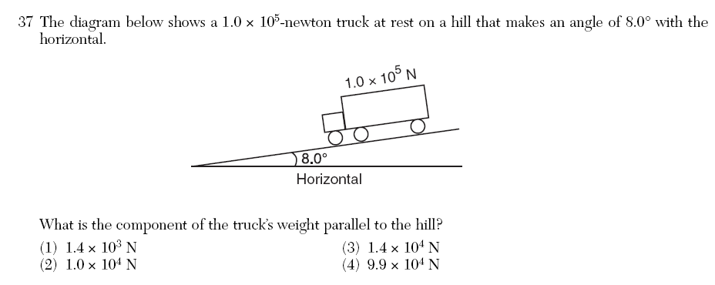

- On a hill, the normal force is calculated by:

mg cos θ

For Example:

7.) Jason snowboards down a hill that has an incline of 20 degrees. Assuming Jason’s weight is 700 Newtons, determine the normal force of the hill exerted on Jason.

