Name:________________________________

Chapter 5- Forces Regents Physics

Hooke’s Law (Spring Force)
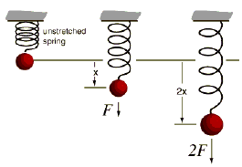

Naturally, when a force is applied to a string, the string either gets longer or shorter. The compression or elongation of a spring is the change in spring length from its equilibrium position when a force is applied to it. Its equilibrium position is the unstretched length of the spring.

Provided the elastic limit of the spring is not exceeded (otherwise the spring breaks!), the compression or elongation of a spring is directly proportional to the applied force. Therefore, if the force applied is doubled, then the elongation or compression of the string is doubled. This relationship is called Hooke’s Law:

F_{s} = kx

In the equation, k is the spring constant (units of N/m). x is the elongation or compression from the unstretched length. x is usually given in centimeters so make sure to convert to meters!

For Example:

- The unstretched length of a certain spring is 20 cm. If the length of the spring is stretched out to 50 cm, determine the elongation of the spring in meters.

- The spring constant of a certain spring is 40 N/m. If the elongation of the spring is 0.3 meters, determine the force applied to the spring.

- A force of 10 Newtons is applied to a spring with a spring constant of 30 N/m. Determine the elongation of the spring.

- A mass of 4 kg is hung from a spring. If the spring’s elongation is 0.6 meters, determine the spring constant of the spring. (Hint: what creates the force?)

