Historical Figures Review Sheet:
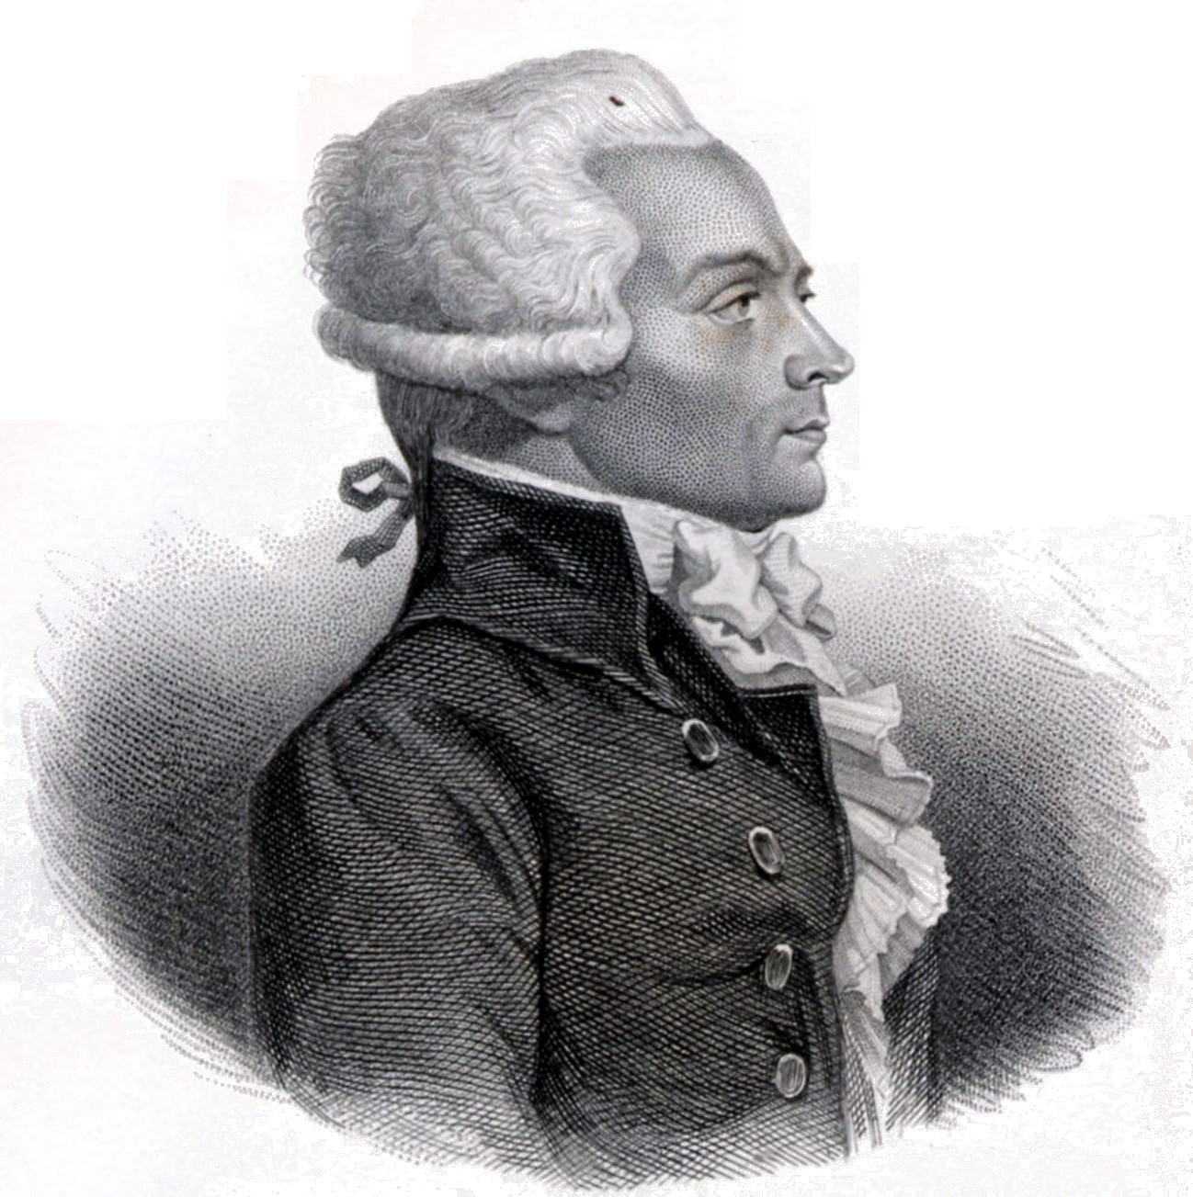
Maximilien Robespierre

How he came to power (Historical Circumstances):

Major Beliefs: Achievements and/or Goals:

Impact on Society (positive and/or negative): Policies/Methods used to achieve goal(s):

