Useful Resources and FAQs
Climate Poster Project
Due Friday, Nov 13th

What sources should I use to find my information?

- Use Ms. Oshan’s website for all useful links
- You may also additional websites in your research

What should my climate summary paragraph look like?

See the example below (words are underlined for emphasis):

Marine climate regions are located primarily on the west coasts of continents, such as western Europe, the northwestern United States, Chile, New Zealand, and also on the southeast coast of Australia and South Africa. These areas are consistently damp and rainy, receiving about 2 to 5 inches of precipitation each month, with occasional snow in the winter. Average monthly temperatures range from 40º to 70º F. Typical vegetation includes mixed forests of coniferous and deciduous trees, with woody shrubs that provide shelter and food for wildlife such as bears, wolves, cougars, and squirrels, as well as many different types of birds, fish and amphibians.

What should my photo captions say?

Example:
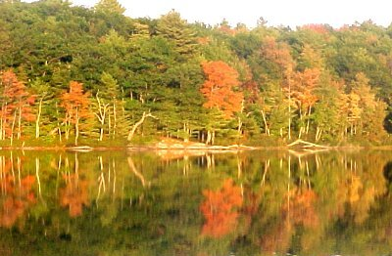

This photo was taken by a lake outside of Portland, Maine. As you can see, a humid continental climate has both evergreen and deciduous trees, which lose their leaves in autumn. Humid continental climates have four distinct seasons. Autumn starts out warm but then becomes cooler, with moderate precipitation. Photo from www.portlandme.about.com/library/blleafwatch.htm.

