Name:________________________________

Chapter 4 – Vectors Regents Physics

Vectors and Trigonometry

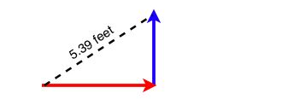
One of the most common cases of concurrent forces are those acting at right angles to each other. For these, simply use the Pythagorean Theorem to find the resultant vector. A picture will always help!!!

For Example:

- An airplane travels 300 mph to the East while a wind blows it to the North at 400 mph. Determine the resultant velocity of the airplane.

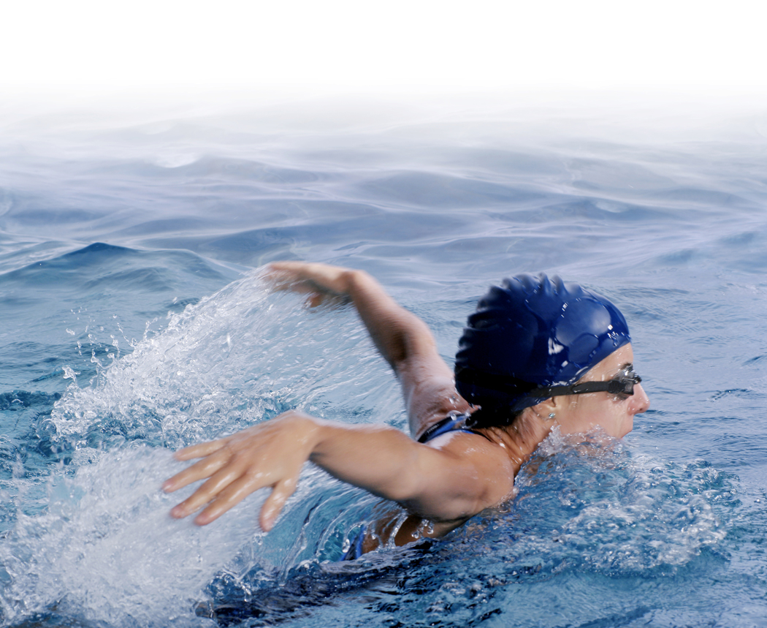

- A swimmer attempts to cross a river at 6 m/s but the current is flowing downstream at 2 m/s. What is the swimmer’s resultant velocity?

Many times, the Regents will also want the direction of the resultant velocity. To do this, draw a picture representing a triangle. Use the inverse tangent function to find the appropriate angle (tan θ = y-component/x-component). Then use compass directions to explain the direction of the angle.

For Example:

- Find the direction of the resultant in Example 1.

- Find the direction of the resultant in Example 2.

Just as force vectors can be added to provide the magnitude and direction of the resultant force, force vectors can be resolved or broken up into component vectors. The process of determining the magnitude and direction of the components of a force is called resolution of forces. Although a vector could be resolved into an UNLIMITED number of components, it is usually resolved into two components that are perpendicular to each other (just like we did with projectile motion!)

Your reference tables will have the following to represent the resolving of vectors. Any vector A, making angle θ with the horizontal, the following apply:

A_{x} = A cos θ
A_{Y} = A sin θ

For Example:

- A plane takes off at 300 m/s at an angle of 25 degrees to the ground. Find the perpendicular components of the velocity vector.



- Courtney pulls the desk across the room with 30 Newtons of force at an angle of 15 degrees to the horizontal. Determine the x and y components of the resultant.

Equilibrium

Equilibrium occurs when the resultant vector is zero. An object at rest is said to be in static equilibrium. The equilibrant is the vector which places another vector in equilibrium.

For Example:

- A force of 10 Newtons is applied to an object to the East. Determine the equilibrant of this vector. (What vector will place this force into equilibrium or resultant = 0)

- A force of 20 Newtons at 30º north of west acts on an object. Determine the equilibrant of this vector.

