**Parallel Lines Cut by a Transversal**

When two parallel lines are cut by a transversal (i.e., a third line intersects the two parallel lines), a number of relationships exist between the resulting angles.

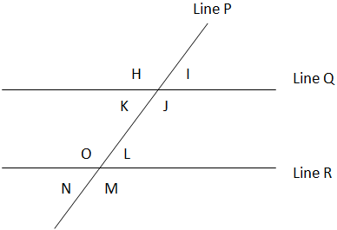

* **Alternate Interior Angles** Are Equal: K = L; O = J
* **Alternate Exterior Angles** Are Equal: H = M; N = I
* **Corresponding Angles Are Equal:** K = N; J = M; H = O; I = L
* **Non-Alternate Interior Angles Are Supplementary**: L + J = 180; K + O = 180
* **Vertical Angles**: O=M, N = L, H= J, K=I

**Supplementary Angles** = 180 degrees. Add K + H = 180. K + J = 180