Nombre________________________________________La fecha_____________________Período______

**Los quehaceres domésticos**

|  |  |
| --- | --- |
| To make the bed |  |
| To wash the dishes |  |
| To dry the dishes |  |
| To wash the clothes |  |
| To put the clothes in the washing machine |  |
| The dryer |  |
| To iron the clothes |  |
| To clean the room |  |
| To cook dinner |  |
| To prepare dinner |  |
| To vacuum |  |
| To take out the garbage |  |
| To feed the pet |  |
| To dust |  |
| To cut the lawn |  |
| To plant the flowers |  |
| To wash the car |  |

**Escribe un mandato correspondiente de cada cuarto en la casa:**

1. The kitchen

__________________________________________________________________________________

2. the bathroom

__________________________________________________________________________________

3. the bedroom

__________________________________________________________________________________

4. the living room

__________________________________________________________________________________

__________________________________________________________________________________

5. the garden/backyard

__________________________________________________________________________________

__________________________________________________________________________________

6. the dining room

__________________________________________________________________________________

7. the garage

__________________________________________________________________________________

8. the basement

__________________________________________________________________________________

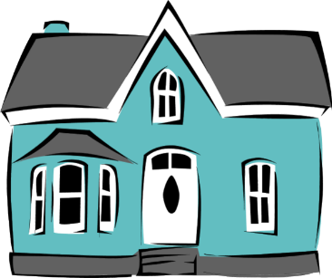

|  |  |
| --- | --- |
| To make the bed | **Hacer la cama** |
| To wash the dishes | **Lavar los platos** |
| To dry the dishes | **Secar los platos** |
| To wash the clothes | **Lavar la ropa** |
| To put the clothes in the washing machine | **Poner la ropa en la lavadora** |
| The dryer | **La secadora** |
| To iron the clothes | **Planchar la ropa** |
| To clean the room | **Limpiar el cuarto** |
| To cook dinner | **Cocinar la cena** |
| To prepare dinner | **Preparar la cena** |
| To vacuum | **Pasar la aspiradora** |
| To take out the garbage | **Sacar la basura** |
| To feed the pet | **Dar comida a la mascota** |
| To dust | **Sacudir** |
| To cut the lawn | **Cortar el césped** |
| To plant the flowers | **Plantar las flores** |
| To wash the car | **Lavar el coche** |