**Name:________________________________**

**Chapter 6- Gravitation Regents Physics**

**Newton’s Universal Law of Gravitation**

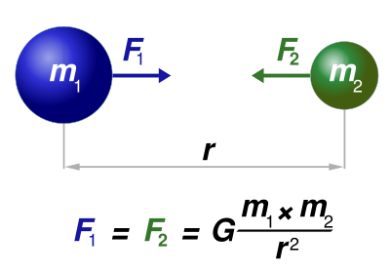

According to Newton’s universal law of gravitation, **any two bodies of mass attract each other with a force that is directly proportional to the product of their masses and inversely proportional to the square of the distance between them.** In other words, as **mass** **increases**, the **force of attraction increases**. As **distance increases**, the **force of attraction decreases exponentially**. The attractive force between two objects due to their masses is called **gravitational force**. We have already discussed the gravitational force between masses and different planets (weight). The force is given by this equation:



**Fg** is the force due to gravity in **Newtons**, **m1** and **m2** are the masses of the objects in **kilograms**, **r** is the **distance between the centers of the objects in meters**, and **G** is the universal gravitational constant (given in your reference tables):

**G= 6.67 x 10 -11**



According to the law, **the gravitational force that mass m1 exerts on mass m2 is equal in magnitude and opposite in direction to the gravitational force that mass m2 exerts on mass m1** (Consistent with Newton’s third law).

**Notes:**

* **Gravity is ALWAYS attractive!**
* **Gravity is the weakest force in the universe!**

**For Example:**

1. If the distance between two masses is **doubled**, what happens to the magnitude of the gravitational force between the masses?

What if it is **tripled**?

1. Determine what happens to the magnitude of the gravitational force between two masses if:
   1. One of the two masses is double.
   2. Both of the masses are doubled.
   3. One mass is doubled while the other mass is quartered.
   4. One mass is doubled while the distance is doubled.
   5. Both masses are doubled while the distance is halved.
2. Sketch a graph representation of:
   1. **Gravitational Force vs. Distance**
   2. **Gravitational force vs. Mass**
3. Determine the magnitude of the gravitational force of attraction between a 400-kg mass and an 800-kg mass separated by a distance of 0.005 meters.
4. The force of attraction between a 2,000-kg mass and a 4,000-kg mass is 4 x 10 -12 Newtons. Determine the distance separating the two objects.
5. An object with a mass of 10,000 kg attracts another mass that is 4.0 meters away with a force of 6 x 10-4 Newtons. Determine the mass of the other object.
6. Calculate the gravitational attraction between the Earth and the Moon.

**Gravitational Field Strength**

A region in space where a test particle would experience a gravitational force is called a **gravitational field**. Every mass is surrounded by a gravitational field. Vectors are used to map out gravitational fields which are **ALWAYS ATTRACTED** to the mass.

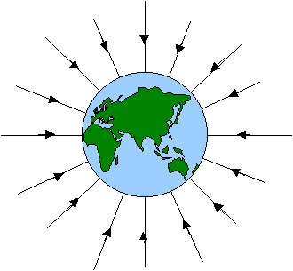

When we calculate the **gravitational field strength**, we are also calculating the **acceleration due to gravity** near that mass. Therefore, the equation for gravitational field strength is:



**Note:** Typically, gravitational field strength has units of **N/kg** and acceleration due to gravity has units of **m/s2**.

8.) What is the field strength of a planet where a man of 85 kg weighs 400 Newtons?