**Name:________________________________ Regents Physics**

**Chapter 7- Momentum**

**Impulse**

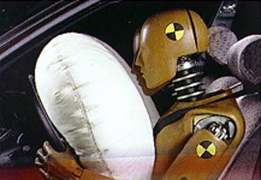**Impulse** **(J)**, a **vector quantity**, is the **change in momentum**. Impulse is a **vector quantity** and the direction of the impulse is the same as the direction of the change in momentum. The units for impulse is **N.s**.

**J = Δp = pf - pi = mvf - mvi**

**For example:**

1.) A 400-kg go-cart begins at rest and obtains a velocity of 20 m/s east after 10 seconds.

a.) What is the object’s initial momentum?

b.) What is the object’s final momentum?

c.) What is the object’s change in momentum?

d.) What is the impulse applied to the object?

2.) After 20 seconds, a 200-kg object increases its velocity from 15 m/s to 40 m/s. Determine the impulse applied to the object.

3.) A 50-kg rock is rolling 20 m/s **east**. Dan decides to push the rock in the other direction for 15 seconds. If the object is now travelling 10 m/s **west**, determine the impulse applied to the rock by Dan.

**Impulse and Force**

Recall that a force applied to an object will accelerate the object. If an object moves faster, there will have been a **change in momentum**. Therefore, force must be related to the impulse applied to an object. In fact, the product of the force applied to an object and the time during which the force acts is the **impulse** applied to the object. The equation is:

**J = Ft**

Since force is in Newtons and time is in seconds, we find that impulse is in **N.s**. A quick derivation of this equation can show that impulse is in fact the change in an object’s momentum.

If we were to graph **force vs. time on a graph**, impulse can be found by finding the **area under the plotted line**.

**For Example:**

4.) Determine the impulse of this object:

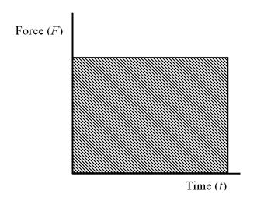

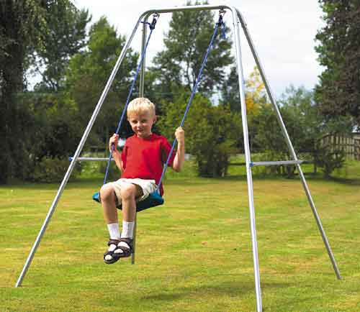5.) Anthony pushes Kristin (at rest) on a swing set. If Anthony pushes with a force of 200 Newtons for 2 seconds, determine the impulse applied to Kristin.

* Recognize that if **J = Δp** and **J = Ft**, it follows that: **Δp = mvf - mvi = Ft**. Once again, all this says is that the change in momentum (impulse) is equal to the product of the force and time during which the force acts.
* **Note:** For most of these problems, it is easiest to find out what **J** is then to set it equal to either **mvf - mvi** or**Ft**.

6.) While driving her car at 40 m/s, Andrea (with a mass of 50-kg) stops short to avoid hitting a squirrel crossing the road. If the seat belt is in contact with Andrea for 0.5 seconds, determine:

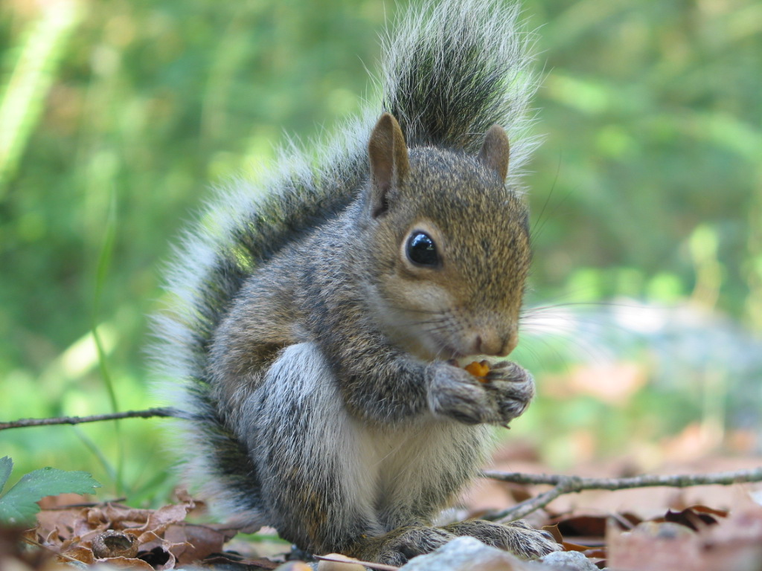 a.) Andrea’s initial momentum

b.) Andrea’s final momentum

c.) What is the change in momentum (impulse)?

d.) What is the force that the seatbelt exerts on Andrea?

7.) In a fit of rage, Erin throws a 0.5-kg apple at the chalkboard with a velocity of 25 m/s. If the apple hits the chalkboard with a force of 50 Newtons and comes to a stop, determine the time that the apple was in contact with the chalkboard.



8.) Tom is driving in his 1,000-kg car at 30 m/s. Tom steps on the accelerator which makes the engine apply a 4000 Newton force for 3 seconds. What is the final velocity of the car?

9.) An impulse of 4000.0 N.s is applied to a 30-kg object moving at 100 m/s. What is the velocity after this impulse is applied?

10.) Mike hits a 0.14-kg baseball to the west at 100 m/s. Determine the initial velocity of the baseball if Mike’s bat provides a force of 100 Newtons for 0.25 seconds to the ball.



11.) A constant unbalanced force acts on an object for 10 seconds producing an impulse of 20.0 newton-seconds east. Determine the magnitude and direction of force.

12.) An impulse of 200 newton-seconds west is applied to a 4-kg object initially moving 100 m/s to the east. Determine the final momentum of the object. **(Make sure to include direction!)**

13.) A force of 20 Newtons east is applied to a 0.4-kg object moving 30 m/s east to increase its velocity to 50 m/s east. Determine the amount of time that the force was applied.