**Chapter 1- Kinematics Regents Physics**

**One-Dimensional Motion - Speed vs. Velocity**

***1. SPEED***

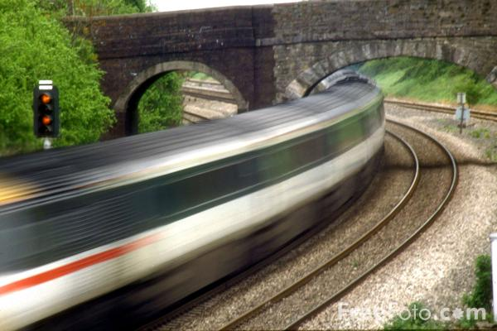An object is considered moving when its position changes with time. The **speed** of an object is the **distance** the object moves per unit of **time**. Since we are talking about **distance** and not displacement, speed is a **scalar** quantity. The **average speed** of an object is given by the following equation:

The unit for distance is meters (m) and the unit for time is seconds (s) which makes speed have units of **m/s**. If speed remains the same throughout the time period, the object is said to have **constant** speed or **uniform motion**. If the speed varies, the motion is **non-uniform**.

**For example:**

1. The school bus covers a distance of 400 meters in 20 seconds. What is the **average speed** of the bus?
2. Johnny rides his bicycle 40 meters north and 20 meters east in 10 seconds. What is Johnny’s **average speed**?
3. A bowling ball races down the 19 meter alley in 3 seconds. What is the ball’s average speed?

***2. VELOCITY***

The **velocity** of an object is the time rate of change of its **displacement**. Therefore, velocity is a **vector** quantity having both magnitude and direction. In velocity problems, make sure you find the displacement first!

The average velocity of an object is given by the equation:

Pretty much the same equation as before yielding the same units (m/s); only this time you are using **displacement (direction matters!!!)** Make sure your answer includes direction.

**For example:**

1. Johnny rides his bicycle 40 meters north and 20 meters east in 10 seconds. What is Johnny’s **average velocity**?
2. A fighter jet flies 3 km west and then 2 km east in 8 minutes. Determine the jet’s average velocity. (Remember to convert!)
3. Lucy runs to her classroom which is 20 meters away. She forgets her physics book in her locker and must return 20 meters in the direction from whence she came. If her total trip takes 3 minutes, what is Lucy’s average velocity?
4. Ron takes his car out for a joy ride and travels 400 meters north. He then travels 100 meters east and picks up his buddy Chris. They then stop at a 7-11 which is 200 meters south from Chris’s house. If the total trip takes 10 minutes, determine the average velocity of Ron’s car. **(Draw a picture!)**