Name:

*Base your answer to question 1 on the passage below and on your knowledge of social studies.*

The “Middle East” is not a term Middle Easterners gave themselves, but a British term borne of a colonial, European perspective. The term’s origins are seeped [steeped] in controversy for having originally been a European imposition of geographic perspective according to European spheres of influence. East from where? From London. Why “Middle”? Because it was half-way between the United Kingdom and India, the Far East.…

Pierre Tristam, “What is the Middle East?”

1. Which term is most closely associated with the main idea of this passage?
   * 1. Interdependence (3) containment
     2. pacifism (4) ethnocentrism
2. In what way were Korea and Germany similar after World War II?
   * 1. They refused to align with the superpowers.
     2. Their former emperors stood trial for war crimes.
     3. Both remained divided during the Cold War.
     4. Ethnic tensions threatened civil war in each country.
3. A goal of both the European Union (EU) and the North American Free Trade Agreement

(NAFTA) is to

* + 1. reduce trade barriers between member nations
    2. decrease competition between key industries
    3. control the supply of oil available to industrialized nations
    4. increase nationalism in western nations

1. Which Chinese leader is most closely associated with leading the Great Leap Forward and the Cultural Revolution?
   * 1. Sun Yixian (Sun Yat-sen)
     2. Jiang Jieshi (Chiang Kai-shek)
     3. Mao Zedong
     4. Deng Xiaoping
2. Why did large numbers of Hindus and Muslims migrate immediately after India gained its independence?
   * 1. Many jobs were being outsourced overseas.
     2. The government offered housing incentives in newly developed areas.
     3. Religious pilgrimages to neighboring countries were required based on their beliefs.
     4. The subcontinent was divided into countries based primarily on the location of religious majorities.
3. F. W. de Klerk and Nelson Mandela received the Nobel Peace Prize for their work to end the
   * 1. foreign control of the diamond mines
     2. discriminatory policy of apartheid
     3. anarchy in Somalia
     4. Boer War
4. Pol Pot, the Khmer Rouge, the “killing fields,” and Year Zero are all associated with a violent period in which country?
   * 1. Vietnam (3) China
     2. Cambodia (4) Korea
5. Which condition, in combination with drought, has most directly forced the migration of people out of the southern regions bordering the Sahara?
   * 1. urbanization (3) wildlife tourism
     2. coastal pollution (4) desertification

*Base your answer to question 9 on the cartoon below and on your knowledge of social studies.*

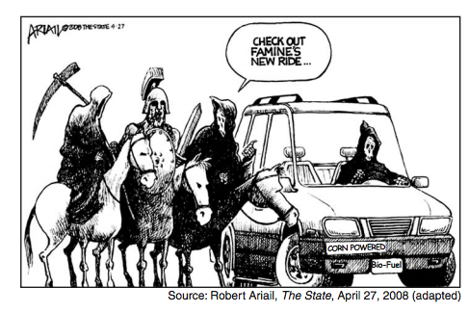

1. What is the main idea of this cartoon?
   * 1. Riding a horse is more dangerous than riding in an automobile.
     2. The use of bio-fuels made from corn will improve automobile safety.
     3. Using corn to make bio-fuels for automobiles will increase food shortages.
     4. Feeding corn to horses is less efficient than using it to make fuel for automobiles.

*Base your answer to question 10 on the passage below and on your knowledge of social studies.*

… For Ukraine, however, contamination via river water is still a major problem, since most of the rivers flow southwards. To slow the spread of radiation, protective dams were built along the Dnieper after the accident. “But of course not all riverbanks could be protected in this way,” as the Ukrainian government agency Chernobyl Interin form points out in its summary of the situation. “Particularly during flooding, radiation is still leached into rivers. This is a particular threat for the 30 million people who obtain their drinking water from the Dnieper basin.” …

* + Chernobyl.info

1. The aftermath of which problem is being described in this passage?
   * 1. volcanic eruption (3) global warming
     2. nuclear disaster (4) deforestation
2. What is one factor that has affected economic development in southern African nations in the 21st century?
   * 1. reliance on coffee exports
     2. equal distribution of wealth
     3. establishment of communist governments
     4. spread of the AIDS epidemic
3. The purpose of both the Truman Doctrine and the Marshall Plan was to
   * 1. support the construction of the Iron Curtain
     2. increase membership in the United Nations
     3. prevent the spread of communism
     4. attempt to solve world hunger
4. Which change occurred immediately after the region of British India gained its independence in1947?
   * 1. India became an ally of the Soviet Union.
     2. India adopted Islam as the official state religion.
     3. The region was partitioned into two separate states.

(4) A military dictatorship took control of the entire region.

1. In the struggle to gain independence for their countries, both Kwame Nkrumah and Ho Chi Minh relied on
   * 1. nationalist sentiments
     2. trench warfare
     3. collective security agreements
     4. nonviolent resistance
2. The Organization of Petroleum Exporting Countries (OPEC) was formed with the intent of
   * 1. stabilizing the supply of oil to Japan
     2. cutting off the supply of oil to the United States and its allies
     3. increasing the supply of oil available for use within Middle Eastern countries
     4. controlling the supply of oil to raise prices

*Base your answer to question 16 on the cartoon below and on your knowledge of social studies.*

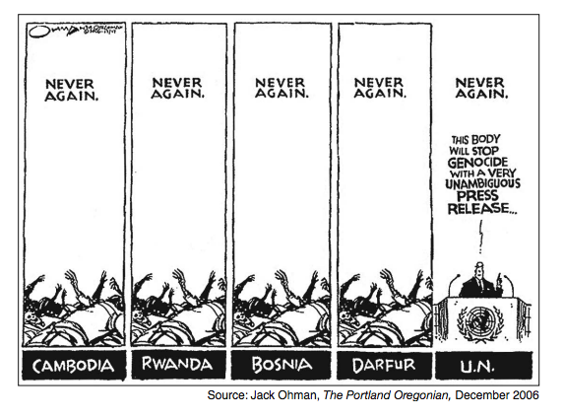

1. What is the key idea of this cartoon?
   * 1. Genocide in Cambodia, Rwanda, Bosnia, and Darfur has been stopped.
     2. Human rights issues are best dealt with by the United Nations.
     3. The United Nations has not been effective in ending genocide.
     4. Fear of war crimes trials has brought peace to troubled regions.
2. Both the division of Germany and the division of Korea following World War II led to
   * 1. uneven economic development between the divided portions
     2. democratic governments for all citizens
     3. open warfare between the divided parts
     4. space exploration agreements with the superpowers
3. Changes in the political borders of Eastern European countries during the 1990s were a result of the
   * 1. failure of communism
     2. expansion of the Warsaw Pact
     3. end of free trade
     4. decline of the North Atlantic Treaty Organization (NATO)

*Base your answer to question 19 on the chart below and on your knowledge of social studies.*

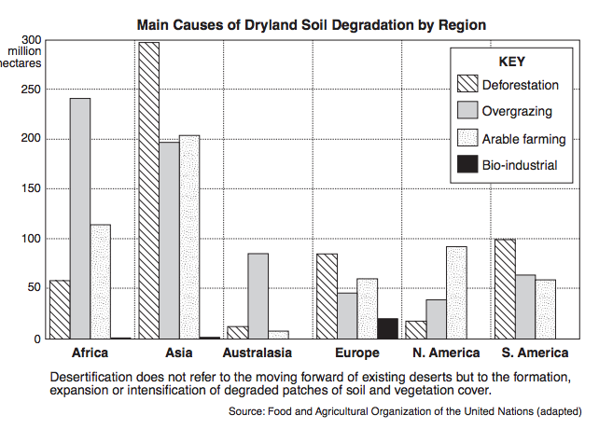

1. What is a valid conclusion based on the information shown in this chart?
   * 1. The primary cause of soil degradation throughout the world is bio-industrial.
     2. Deforestation causes soil degradation to more hectares of land in South America than in Asia.
     3. The largest number of hectares affected by soil degradation due to overgrazing is located in Africa.
     4. The fewest number of hectares affected by soil degradation due to arable farming is located in North America.

*Base your answer to question 20 on the diagram below and on your knowledge of social studies.*

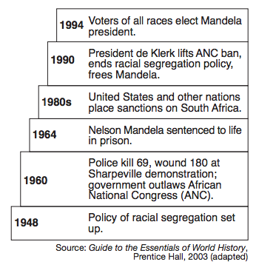

1. Which policy is the focus of this diagram?
   * 1. apartheid (3) appeasement
     2. isolationism (4) neutrality
2. One way in which the Chinese Revolution (1945–1949) and the Cuban Revolution (1956–1959) are similar is that the leaders of both revolutions
   * 1. embraced capitalist ideas
     2. rejected industrial development
     3. used peaceful methods to achieve their goals
     4. relied on support from the peasants
3. Which statement about Shah Reza Pahlavi and the Iranian Revolution is an opinion rather than a fact?
   * 1. Shah Reza Pahlavi was supported by major Western powers.
     2. Members of the Islamic clergy opposed Shah Reza Pahlavi.
     3. The primary cause for the revolution was the exile of Shah Reza Pahlavi’s critics.
     4. Supporters of Ayatollah Ruhollah Khomeini overthrew Shah Reza Pahlavi.

*Base your answer to question 23 on the poem below and on your knowledge of social studies.*

In The Quiet Land (by Daw Aung San Suu Kyi)

In the Quiet Land, no one can tell

if there’s someone who’s listening

for secrets they can sell.

The informers are paid in the blood of the land

and no one dares speak what the tyrants won’t stand.

In the quiet land of Burma,

no one laughs and no one thinks out loud.

In the quiet land of Burma,

you can hear it in the silence of the crowd.…

1. The author is using this poem to condemn
   * 1. oppression (3) nonviolence
     2. illiteracy (4) containment
2. By the late 1970s in China, the growing size of its population influenced the government’s decision to
   * 1. encourage people to migrate to other countries
     2. force families to work on communes
     3. engage in wars to gain territory
     4. institute a one-child policy
3. During the Cold War, which event occurred last?
   * 1. Cuban missile crisis
     2. destruction of the Berlin Wall
     3. Berlin airlift
     4. launch of Sputnik by the Soviet Union

*Base your answer to question 26 on the map below and on your knowledge of social studies.*

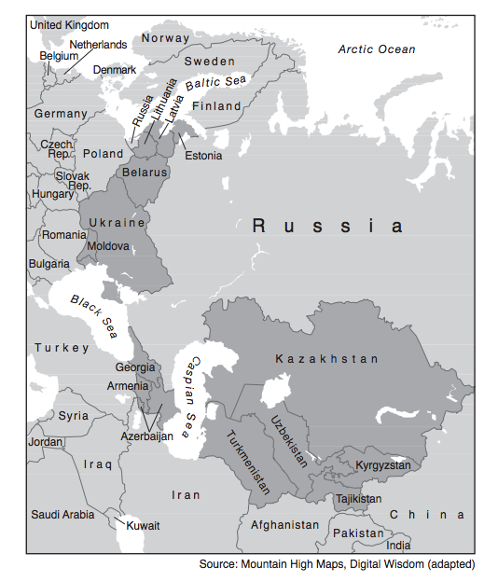

1. What do the darkest areas of this map represent?
   * 1. former republics of the Soviet Union
     2. current members of the European Union
     3. original member countries of the Warsaw Pact
     4. recent additions to the Organization of Petroleum Exporting Countries (OPEC)

*Base your answer to question 27 on the passage below and on your knowledge of social studies.*

… The expansion of communications meant that the world got more deeply connected and became “flat,” in Thomas Friedman’s famous formulation. Cheap phone calls and broadband made it possible for people to do jobs for one country in another country—marking the next stage in the ongoing story of capitalism. With the arrival of big ships in the fifteenth century, goods became mobile. With modern banking in the seventeenth century, capital became mobile. In the 1990s, labor became mobile. People could not necessarily go to where the jobs were, but jobs could go to where people were. And they went to programmers in India, telephone operators in the Philippines, and radiologists in Thailand. The cost of transporting goods and services has been falling for centuries. With the advent [coming] of broadband, it has dropped to zero for many services. Not all jobs can be outsourced—not by a long shot—but the effect of outsourcing can be felt everywhere.…

Fareed Zakaria, The Post-American World, W. W. Norton & Company, 2008

1. Which conclusion about the global economy is best supported by this 2008 passage?
   * 1. The labor market in Asia relies on child labor.
     2. Technology has decreased the cost of doing business.
     3. Capitalism has not met the needs of the working class.
     4. Globalization is creating fewer jobs.
2. Which event in the history of the Indian subcontinent occurred last?
   * 1. Salt March
     2. Amritsar Massacre
     3. creation of Pakistan
     4. Sepoy Rebellion
3. In the post–World War II time period, the purpose of both the North Atlantic Treaty Organization (NATO) and the Warsaw Pact was to
   * 1. discourage religious toleration
     2. establish a military alliance
     3. promote economic self-sufficiency
     4. eliminate political corruption
4. Fidel Castro was successful at leading a revolution in Cuba because he gained the support of
   * 1. wealthy landowners (3) peasant farmers
     2. government officials (4) foreign investors
5. Which Southeast Asian nation fought in wars against Japan, France, and the United States during the 20th century?
   * 1. Myanmar (Burma) (3) Philippines
     2. Thailand (4) Vietnam
6. Which country was ruled by Pol Pot and the Khmer Rouge?
   * 1. Afghanistan (3) Cambodia
     2. Kazakhstan (4) Bangladesh
7. The primary goal of the student protests in Tiananmen Square (1989) was to
   * 1. support the policies of the Chinese Communist Party

(2) decrease the amount of Western influence in China

(3) encourage the spread of industrialization throughout China

(4) increase political freedom and rights in China

*Base your answer to question 34 on the passage below and on your knowledge of social studies.*

...We have triumphed in the effort to implant hope in the breasts of the millions of our people. We enter into a covenant [agreement] that we shall build the society in which all South Africans, both black and white, will be able to walk tall, without any fear in their hearts, assured of their inalienable right to human dignity—a rainbow nation at peace with itself and the world....

* + Nelson Mandela, excerpt from Inaugural Address

1. These words were delivered in 1994 by the newly elected president of South Africa to praise his countrymen’s rejection of
   * 1. nationalism (3) apartheid
     2. Pan-Africanism (4) democracy
2. The policies of the European Union (EU) and the North American Free Trade Agreement (NAFTA) have both resulted in
   * 1. an increase in interdependence
     2. the expansion of totalitarianism
     3. an improvement in containment efforts
     4. the support of isolationist practices
3. Which issue has raised significant environmental concerns in the Amazon Basin?
   * 1. desertification (3) tsunami threats
     2. deforestation (4) acid rain
4. Iran and North Korea attracted worldwide attention in the early 21st century because they both have
   * 1. experienced widespread famine
     2. discovered oil reserves
     3. strengthened humanitarian practices
     4. developed nuclear capabilities
5. In the 1950s, what was the status of most countries in Eastern Europe?
   * 1. members of the Common Market
     2. participants in the Marshall Plan
     3. allies of the United States
     4. satellites of the Soviet Union

*Base your answer to question 39 on the cartoon below and on your knowledge of social studies.*

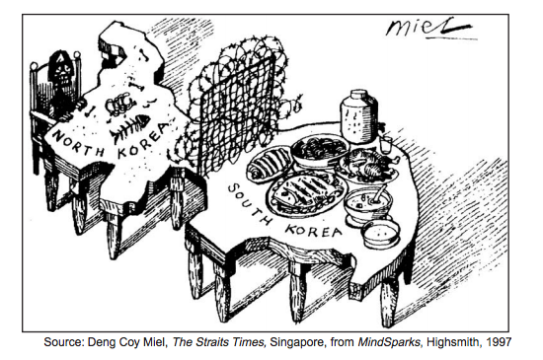

1. What is the main idea of this 1997 cartoon?
   * 1. South Korea has more mineral resources than North Korea.
     2. South Korea has flourished while North Korea is struggling to survive.
     3. North Koreans have chosen to separate themselves from the South Koreans.
     4. North Korea was devastated by the war with South Korea.
2. • Partition of India

• Creation of the State of Israel

• Division of Berlin

Which development directly resulted from each of these events?

* + 1. Large numbers of people migrated.
    2. Nuclear weapons were developed.
    3. Communist governments were established.
    4. Ethnic tensions decreased.

1. In the second half of the 20th century, what was one action taken by both Nelson Mandela and Desmond Tutu?
   * 1. protesting against apartheid in South Africa
     2. supporting the white government of Rhodesia
     3. sending troops to liberate captives in Sudan

(4) leading the independence movement in Ghana

1. In Africa, a key factor that has led to desertification is the
   * 1. loss of animal species
     2. burning of fossil fuels
     3. disposal of toxic waste
     4. overgrazing of livestock
2. Which characteristic is most closely associated with both Pol Pot’s government in Cambodia and Slobodan Milosevic’s government in Yugoslavia?
   * 1. use of terror to achieve political goals
     2. support for freedom of speech
     3. establishment of a theocratic system
     4. respect for ethnic minorities

*Base your answer to question 44 on the cartoon below and on your knowledge of social studies.*

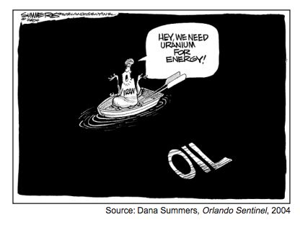

1. What is the main idea of this 2004 cartoon?
   * 1. The lack of energy resources in Iran has led to the importation of uranium.
     2. A drop in oil production has led to an increased dependence on uranium in Iran.
     3. It is questionable whether Iran needs uranium to produce energy.
     4. Frequent oil spills in Iran have resulted in its use of uranium-based fuels.
2. During the Cold War, nations that adopted a policy of nonalignment believed they should
   * 1. be exempt from United Nations decisions
     2. restrict trade with neighboring countries
     3. reject international environmental treaties
     4. follow a course independent of the superpowers
3. The use of the Marshall Plan in Western Europe after World War II strengthened the forces of
   * 1. democracy (3) isolationism
     2. communism (4) autocracy
4. What was a direct result of the Four Modernizations introduced in China by Deng Xiaoping?
   * 1. Freedom of speech was guaranteed.
     2. Goods and services were evenly distributed.
     3. Economic opportunities were expanded.
     4. Fewer consumer goods were produced.
5. Which pair of countries that gained independence in the 20th century experienced the migration of millions of people across their shared borders due to religious tensions?
   * 1. Czech Republic and Slovakia
     2. Kazakhstan and Uzbekistan
     3. Egypt and Libya
     4. India and Pakistan
6. A goal of modern-day religious fundamentalism is to
   * 1. combine the religious teachings of Islam and Christianity
     2. maintain traditional religious values in society
     3. encourage the practice of other religions
     4. adopt secular attitudes instead of religious beliefs
7. What have members of the European Union (EU) and countries of the North American Free Trade Agreement (NAFTA) both attempted to do?
   * 1. reduce regional trade barriers
     2. monopolize iron and steel production
     3. establish collective farms
     4. seize control of the production and distribution of resources

*Base your answer to question 51 on the cartoon below and on your knowledge of social studies.*

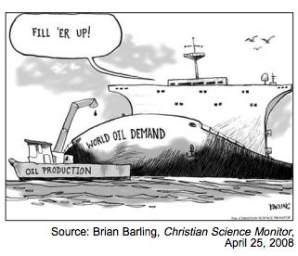

1. What is the main idea of this cartoon?
   * 1. Petroleum is being overproduced.
     2. The demand for petroleum exceeds production.
     3. Fossil fuels are unevenly distributed.
     4. The demands of global environmental groups have increased.
2. The desire of the Kurds and of the Palestinians for independent states is based on the principle of
   * 1. free trade (3) collective security
     2. nationalism (4) modernization
3. Which leader is most closely associated with Desmond Tutu and F. W. de Klerk?
   * 1. Jomo Kenyatta (3) Nelson Mandela
     2. Kwame Nkruhmah (4) Jawaharlal Nehru
4. Since the end of the Cold War, what has been the primary cause of conflicts in Chechnya, Azerbaijan, and Bosnia?
   * 1. religious and ethnic tensions
     2. adoption of capitalism
     3. poor health care and starvation
     4. efforts at Russification

Base your answer to question 55 on the cartoon below and on your knowledge of social studies.

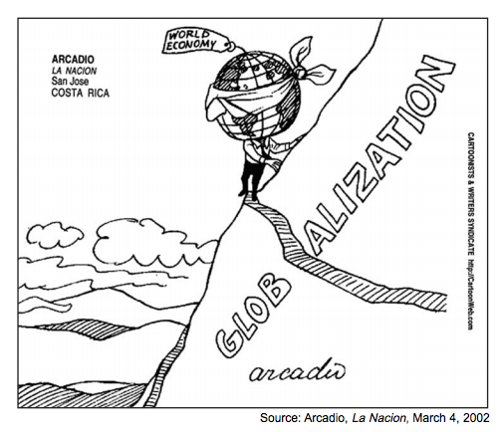

1. Which title best describes the cartoonist’s point of view about globalization?
   * 1. Growing Closer Together
     2. An Economic Miracle
     3. The Road to Stability
     4. An Uncertain Path
2. The southern edge of the Sahara is expanding in process called
   * 1. annexation (3) desertification
     2. conservation (4) desalination
3. Which function of the United Nations is based on the concept of collective security?
   * 1. providing health services
     2. coordinating global peacekeeping
     3. monitoring educational programs
     4. assisting in agricultural research

*Base your answer to question 35 on the cartoon below and on your knowledge of social studies.*

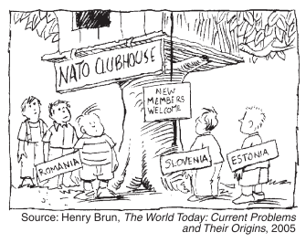

1. In this cartoon, which region is represented by the nations that are seeking membership in the North Atlantic Treaty Organization (NATO)?
   * 1. Latin America (3) Southeast Asia
     2. Central Africa (4) Eastern Europe
2. Which region is most closely associated with conflict in the West Bank, Golan Heights, and the Sinai Peninsula?
   * 1. East Africa (3) Western Europe
     2. Middle East (4) Central Asia
3. In the 1990s, which two countries dominated the headlines because genocide was occurring in those countries?
   * 1. Switzerland and Poland
     2. Vietnam and Singapore
     3. Sudan and Rwanda
     4. Costa Rica and Jamaica
4. Which leader’s policies included glasnost and perestroika?
   * 1. Fidel Castro (3) Mikhail Gorbachev
     2. Nikita Khrushchev (4) Deng Xiaoping

*Base your answers to questions 62 and 63 on the chart below and on your knowledge of social studies.*

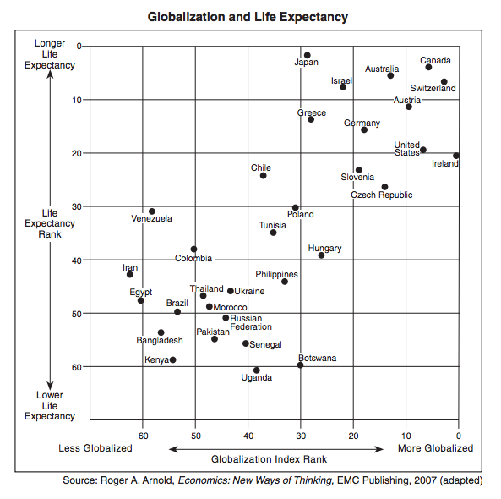

1. Based on the information in this chart, which country has the highest life expectancy?
   * 1. Ireland (3) Venezuela
     2. Japan (4) Greece
2. Based on the information in this chart, which statement is most accurate?
   * 1. Poland is less globalized than Bangladesh.
     2. Switzerland is more globalized than Thailand.
     3. Brazilians tend to live longer than Canadians.
     4. Pakistanis tend to have shorter lives than Ugandans.

*Base your answer to question 64 on the time line below and on your knowledge of social studies.*

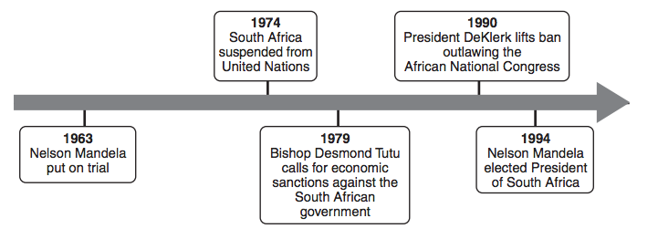

1. Which policy is most closely associated with the events on this time line?
   * 1. nonalignment (3) containment
     2. détente (4) apartheid
2. An objective of the European Union (EU) for the early 21st century is to
   * 1. withdraw from its military alliances
     2. further integrate its economic system
     3. establish a nuclear buffer zone
     4. limit production of alternative fuels
3. “Contaminated Food from China Sold in the United States”

“Computer Virus Shuts Down Hundreds of Businesses Worldwide”

“Multinational Corporations Relocate Factories”

These headlines are directly related to

* + 1. world hunger
    2. overpopulation
    3. global warming
    4. economic interdependence

1. The imaginary line that divided the Western European countries from the Eastern European countries after World War II was known as the

(1) prime meridian (3) Iron Curtain

(2) line of demarcation (4) Berlin Wall

1. Which title best completes the partial outline below?

I. __________________________________

A. Berlin blockade

B. Cuban missile crisis

C. Vietnam War

(1) Path to World War I

(2) Victories for Democracy

(3) Cold War Confrontations

(4) Terrorism in the 20th Century

1. Many scientists believe global warming is the direct result of
   * 1. using solar panels
     2. burning fossil fuels
     3. generating nuclear power
     4. producing hydroelectric power

*Base your answer to question 70 on the graphs below and on your knowledge of social studies.*

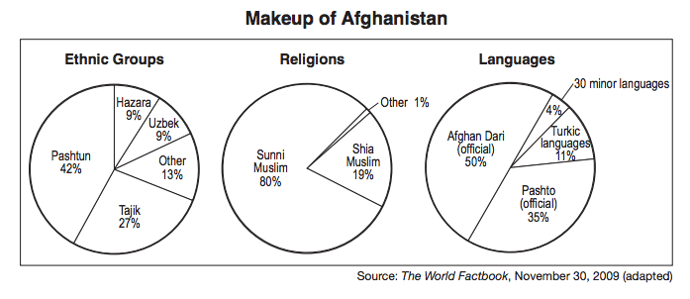

1. Which generalization can best be supported using the information in these graphs?
   * 1. Conflicts between religious groups in Afghanistan have divided the country.
     2. Western countries have had a major influence on the cultural makeup of Afghanistan.
     3. The primary languages in Afghanistan are Turkic.
     4. Diversity is evident in Afghanistan