**Chapter 3- Free Fall Regents Physics**

**One-Dimensional Motion – Freely Falling Objects**

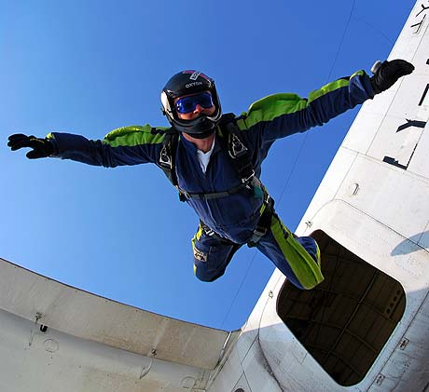Since we have already talked about acceleration, we may now focus on the acceleration due to **gravity**. **Gravity** is the force between the mass of Earth and the mass of any object in the vicinity of Earth. In a **vacuum**, which is a space in which there is no matter, all objects fall with the same acceleration due to gravity. Instead of working in the horizontal direction, we will be using our acceleration formulas in the **vertical** direction.

**vf = vi + at**

**d = vit + at2**

**vf2 = vi2 + 2ad**

For objects accelerating in the **vertical direction only**, we will be using the acceleration due to gravity or:

**g = 9.8 m/s2**

So anytime that you see “a” in an equation, you may substitute it with **9.8 m/s2 ONLY** if you are working in the vertical direction.

**For example:**

1. Joe decides to jump out of an airplane from rest (with a parachute of course!). What will Joe’s velocity be after 5 seconds? (Air resistance is neglected)

**Note:** If an object falls freely from **rest** (air resistance is neglected), its speed and position at any instant in time are given by **vf=at** and **d=1/2 at2** (due to the initial velocity becoming zero and dropping out).

1. Andrea drops an apple from the Empire State Building. How far has it fallen after 8 seconds?

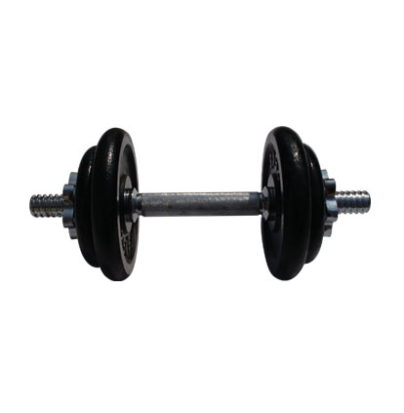

1. A dropped dumbbell (starts at rest) is hurdling towards a helpless worm at 39.2 m/s.
   1. How long has it been falling for?
   2. From what height was it dropped?
2. Chris throws a water balloon off the top of the school building at an unsuspecting victim. If the distance travelled by the balloon is 10 meters and it hit the victim at a final velocity of 20 m/s, how fast did Chris throw the water balloon?
3. Brian takes a slingshot and aims it at a target on the ground. If he shoots the marble at 30 m/s and it takes the marble 0.65 seconds to reach the target, how high was the slingshot from the target?