**Chapter 1- Kinematics Regents Physics**

**One-Dimensional Motion**

***1. DISTANCE***

**Distance** is the **total** length of a path that an object travels. Distance is a **scalar** quantity which means it **only** has magnitude. Therefore, if a problem tells you direction and asks for distance, disregard the directions.

**For example:**

1. Jenny walks 30 meters north, 40 meters south, and 20 meters north. Determine the **distance** travelled by Jenny.
2. A jet takes off from Florida and flies 100 miles north and then 400 miles west. Determine the total **distance** travelled by the jet.
3. A speed boat takes off 400 feet to the north and then travels 600 feet back to the south. Determine the **distance** travelled by the boat.

***2. DISPLACEMENT***

On the other hand, **displacement** is the change in the position of an object described by a vector that begins at the initial position of the object and ends at its final position (shortest way from start point to finish). **Displacement** has **both** magnitude and direction. Therefore, if a problem asks for displacement, **both magnitude and direction must be taken into account.**

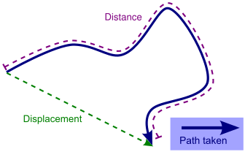

**For example:**

1. Jenny walks 30 meters north, 40 meters south, and 20 meters north. Determine the **displacement** travelled by Jenny.

1. The Port Jefferson ferry travels 20 miles north to Connecticut and then 20 miles south to Long Island. What is the **displacement** of the ferry?

Many displacement problems will require the use of the **Pythagorean Theorem.**

**For example:**

1. An airplane travels 400 meters north and then 300 meters east. Determine the displacement of the airplane. **(Picture may help!)**
2. The city bus travels 5 blocks east, 7 blocks south, and then 2 blocks west. Determine the displacement of the bus. **(Draw a picture!!!)**