**Name:________________________________ Regents Physics**

**Chapter 6- Circular Motion**

**Uniform Circular Motion**

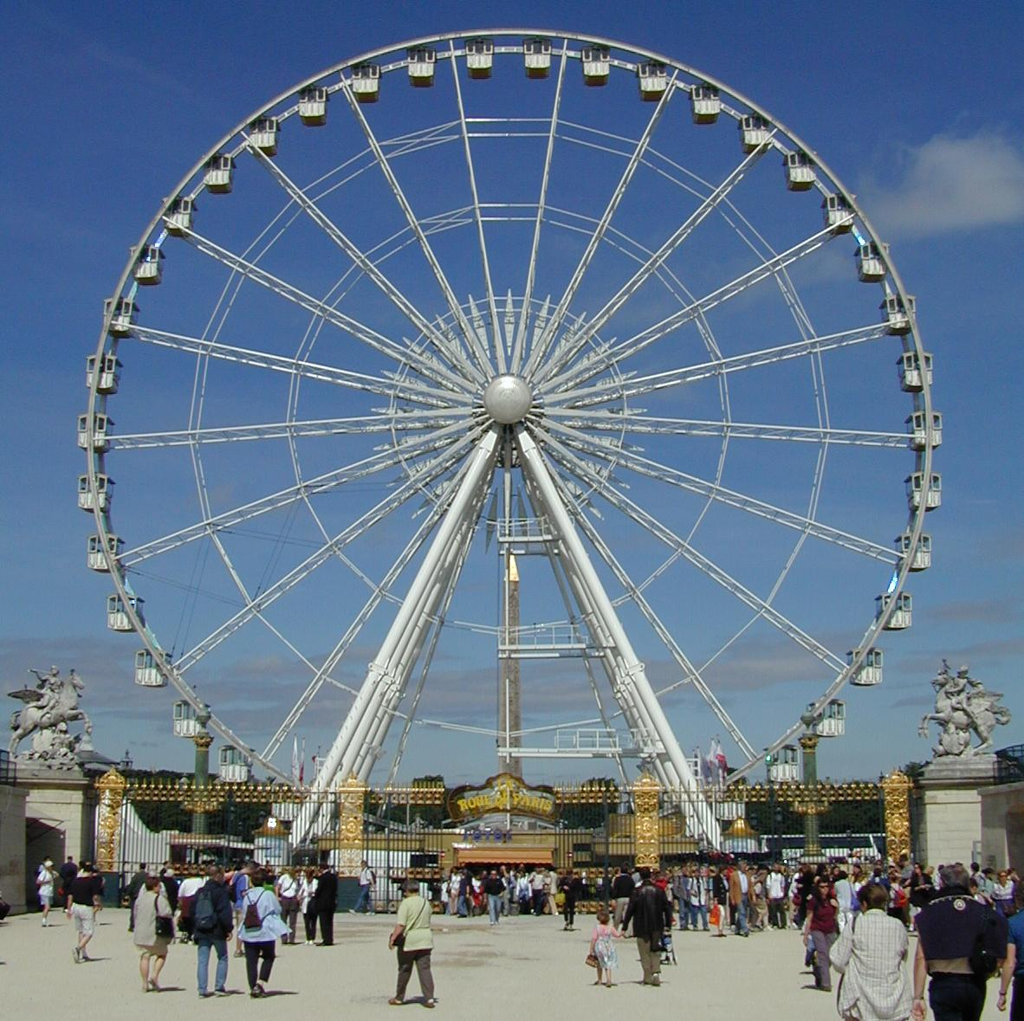

If a force has a constant magnitude and **always acts perpendicular to the direction of the velocity vector**, the object moves in a **circular path at constant speed**, experiencing **uniform circular motion**.

Some examples include making a turn in a car, being on a rollercoaster or ferris wheel, riding a gravitron, swinging a ball on a string, etc.

**Centripetal Acceleration**

An object moving uniformly in a circular path **always** has **centripetal** (“center-seeking”) **acceleration (ac)**, which is an acceleration directed **toward the center of the circle**. The centripetal acceleration is directly proportional to the square of the velocity of the object and inversely proportional to the radius of the circular path in which it travels. Therefore, the equation is:



Acceleration will still be in **m/s2** whereas velocity is in **m/s** and radius is in **m**.

**NOTE:** The centripetal acceleration of an object is **independent of its mass!!!**

**For Example:**

1. Sketch a graph of **centripetal acceleration vs. velocity**.
2. Sketch a graph of **centripetal acceleration vs. radius of path**.
3. If the speed of the object is doubled, the centripetal acceleration of the object is:
4. If the radius of the object is doubled, the centripetal acceleration of the object is:
5. If the speed triples and the radius is halved, the centripetal acceleration is:
6. Fareza decides to take advantage of the snow and perform “doughnuts” in the school parking lot. If the speed of Fareza’s car is 20 m/s and she creates a circle with a radius of 20 meters, determine Fareza’s centripetal acceleration.

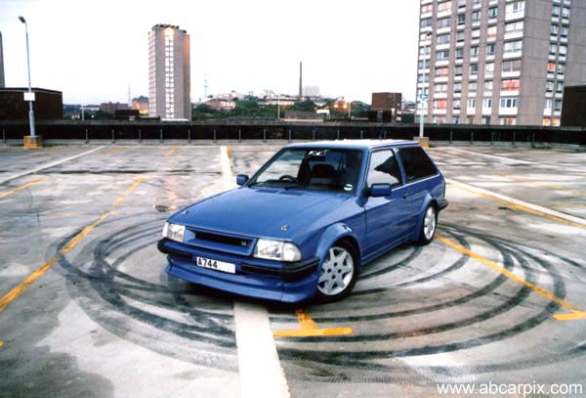

1. Jack hops on a ferris wheel that has a velocity of 5 m/s and a centripetal acceleration of 1.7 m/s2. What is the radius of the ferris wheel?
2. A ball tied to a string maintains a centripetal acceleration of 20 m/s2 and a radius of 3 meters. What is the velocity of the ball?

**Centripetal Force**

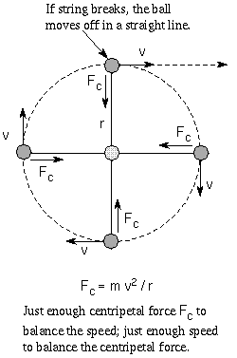

The force needed to keep an object moving in a circular path is called **centripetal force (Fc).** Centripetal force is the vector, directed toward the center of curvature, that produces centripetal acceleration.

Remember Newton’s second law is **F=ma**. Centripetal force can be represented the same way only **substituting centripetal acceleration in for linear acceleration**. Therefore, the new equation is **Fc= mac.** But since we know the equation for centripetal acceleration, we can rewrite this equation to include velocity and radius:



The mass is in **kg**, velocity is in **m/s**, radius is in **m**, and centripetal force is in **N** (or **kg.m/s2**).

**Tangential Velocity**

The direction of an object’s **velocity in circular motion** will always be **tangential** to the circle created (see diagram above). Therefore, if the string attached to the ball were to break, the ball would fly off in the direction tangential to the circle.

**For Example:**

1. In the diagram above, if the string was to break when the ball is in the top position, what direction would the ball continue to move?

In summary:

* **Centripetal acceleration and centripetal force towards middle of the circle.**
* **Velocity is tangential to the circular path.**

**Centripetal Force Examples:**

10.) What is the centripetal force of a 7.0 kg object with a centripetal acceleration of 5 m/s2?

11.) Chang, with a mass of 70-kg, hops on to the gravitron which has a radius of 10 meters and a velocity of 10 m/s. Determine the centripetal force acting on Chang.

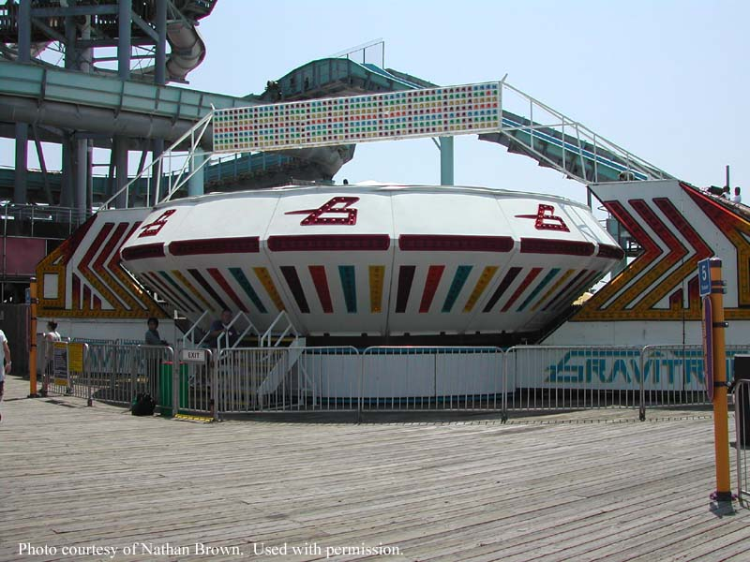

12.) A 4-kg ball is swung around on a string with a length of 4 meters. If the centripetal force is 30 Newtons, determine the velocity of the ball.

13.) A 4,000-kg car makes a turn with a velocity of 20 m/s. If the centripetal force of the car is 600 Newtons, determine the radius of the turn.

14.) A 20,000 kg train makes a turn of 50 meters at a velocity of 40 m/s. Determine the centripetal force of the train.