**Name:________________________________ Regents Physics**

**Chapter 7- Momentum**

**Conservation of Momentum**

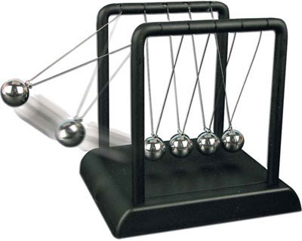**Law of Conservation of Momentum**: the total momentum of the objects in a **closed system** is constant.

*(Note: a* ***closed system*** *is a group of objects not acted upon by any external force)*

Newton’s third law states that every force has an equal and opposite reaction force. Therefore, if one object acts on another object for a specific amount of time, both objects will experience the same amount of impulse but in opposite directions. Therefore:

**pbefore = pafter**

All conservation of momentum problems that we deal with in this class will be with **two objects** either “colliding” or “exploding”. Since the **closed system** involves both objects, we must add the momentum of each object in order to describe the **total** momentum before and/or after the collision/explosion.

**For Example:**

1.) David hops in his 600-kg dune buggy and travels 20 m/s to the east. Meanwhile, Serap drives her 500-kg dune buggy at 30 m/s east and tries to catch David.

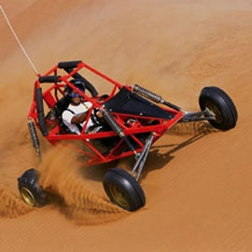 a.) What is David’s momentum?

b.) What is Serap’s momentum?

c.) What is the total momentum of the entire system?

d.) If Serap were to catch up to David and collide with his buggy, what would be the momentum of the system after the collision? **(Conserved!!!)**

2.) After polishing his 2-kg wrestling trophy, Mike sets it down on the ground and walks away to find more polish. Meanwhile, Julie comes around the corner and throws an 8-kg bowling ball towards the unguarded trophy at a velocity of 20 m/s. Before the collision:

a.) What is the initial momentum of the trophy?

b.) What is the initial momentum of the bowling ball?

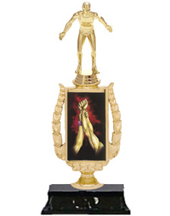

c.) What is the total momentum of the system before the collision?

d.) What is the total momentum of the system after the collision?

e.) After the collision, the bowling ball slows down to a velocity of 12 m/s. What is the velocity of the trophy?

* To do these problems in one step, simply substitute the appropriate variables for the conservation of momentum equation: **pbefore = pafter** which will give you:

**mAvAi + mBvBi = mAvAf + mBvBf**

*Note: There are two objects in the above equation: object* ***A*** *and object* ***B****. The left side is before the collision/explosion (initial velocities) and the right side is after the collision/explosion (final velocities).*

3.) A billiard ball with a mass of 0.16 kg and moving at 30 m/s strikes another 0.16 kg billiard ball at rest. After the collision, the first ball continues moving at 16 m/s. Determine the velocity of the other ball.

4.) A 4,000-kg pick-up truck travelling at 40 m/s collides with a parked car. After the collision, if the pick-up truck continues moving at 15 m/s and the car moves at 50 m/s, determine the mass of the car.

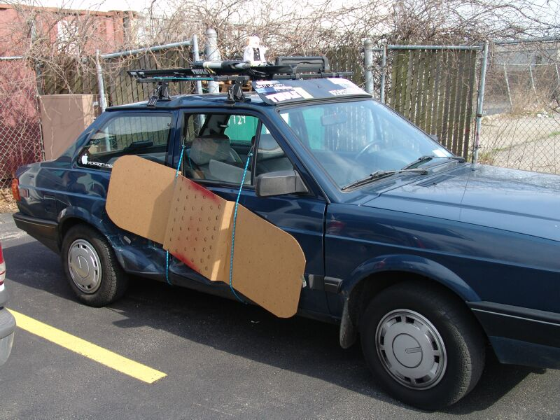

5.) A rock with a mass of 5-kg and moving at 20 m/s collides head on with a 10-kg rock. After the collision, both rocks come to rest. Determine the initial velocity of the 10-kg rock.

**(Be careful with signs!!!)**

6.) Tom’s 100-kg bumper car is traveling east at 10 m/s when it collides head-on with Ray’s 80-kg bumper car traveling west. After the collision, Tom’s car travels west at 20 m/s while Ray’s travels east at 15 m/s. Determine Ray’s initial velocity. **(Be careful with signs!!!)**

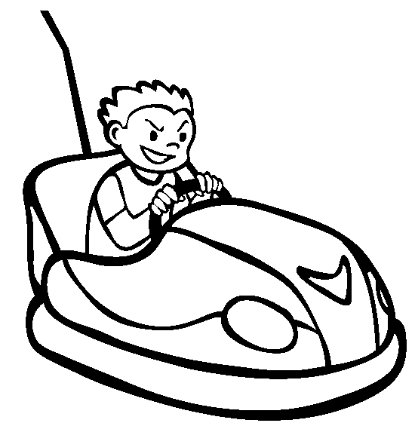

**“Explosion” Problems**

Explosion problem work pretty much the same way except that a projectile is usually fired from a gun or a cannon where the **initial momentum of system is** **zero**. Therefore, simply set the left side of the equation to **zero**. The “kickback” of a gun or cannon is due to conservation of momentum and this is sometimes referred to as the **recoil velocity**.

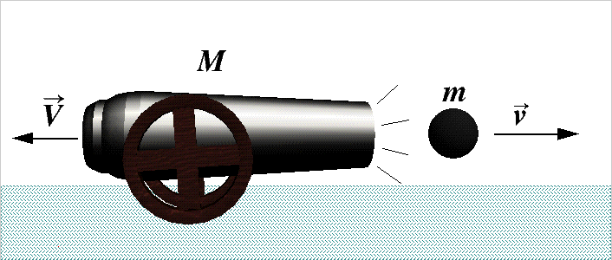

**For Example:**

7.) A 0.05-kg bullet is fired from a 6-kg rifle which is initially at rest. If the bullet leaves the rifle with momentum having a magnitude of 40 kg.m/s, determine the momentum of the recoil.

8.) A 50-kg cannonball is fired from a 200-kg cannon which is initially at rest. If the cannonball leaves the cannon with a velocity of 80 m/s, determine the velocity at which the cannon will recoil with.

9.) A firecracker at rest explodes and sends half of a piece of 0.3-kg flying 30 m/s to the east and another piece flying at 40 m/s to the west. Determine the mass of the other piece.

**“Sticky” Problems**

In “sticky” problems, the problem will tell you that the two colliding objects **stick together**, **lock together**, or **combine** to form one mass. Therefore, on the right-hand side of your conservation of momentum equation, simply add the two masses of the system. The two masses are **now considered one** and both masses will **move with the same final velocity!**

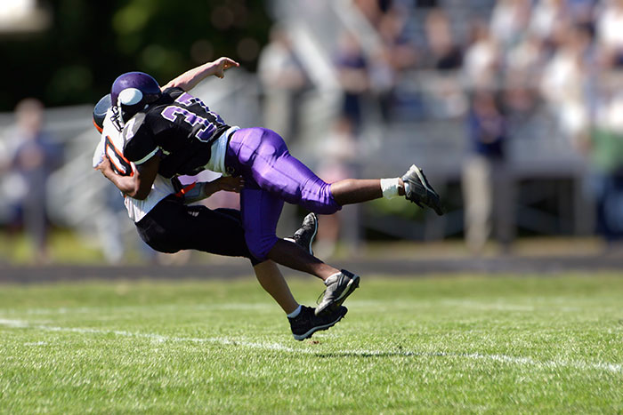

Therefore, the equation looks like this:

**mAvAi + mBvBi = (mA + mB) vf**

***Remember: the final combined mass will only have ONE FINAL VELOCITY!***

10.) In a game of pick-up football, James (with a mass of 80-kg) moves at a velocity of 6 m/s east and tackles Jack (with a mass of 75-kg) who was moving with a velocity of 5 m/s east. After the tackle, both players lock together and move as one mass. Determine the final velocity of the system.

11.) A 2.0-kg cart moving due east at 6 m/s collides with a 3.0-kg cart moving due west. The carts stick together and come to rest after the collision. Determine the initial speed of the 3.0-kg cart.

12.) A 5.0 x 105 kg freight train moving at 40 m/s due east collides and locks up with a 3.0 x 105 kg freight train moving at 60 m/s due west. Determine the final velocity of the combined mass.