**Human Population -** understanding demographic studies:

[**http://tinyurl.com/dss-pop**](http://tinyurl.com/dss-pop)

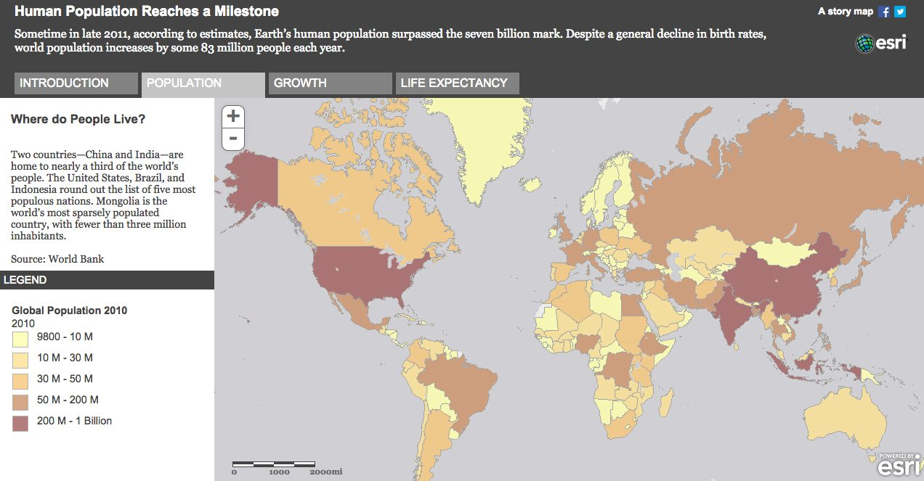

**Questions:**

1. Which are the 3 largest populations in the world?
2. What is the 2010 population of China?
3. How did US population compared to China in 1660 vs. 2010?

Growth-rate:

1. Is US population growth rate of 2010 compared to 2000 increasing?
2. How does US population growth rate of 2000 compared to 1990?

(<http://storymaps.esri.com/7billion/>)

__________________________________________________________________________

**Comparing Unemployment and Population Change:**

**http://tinyurl.com/dss-pop2**

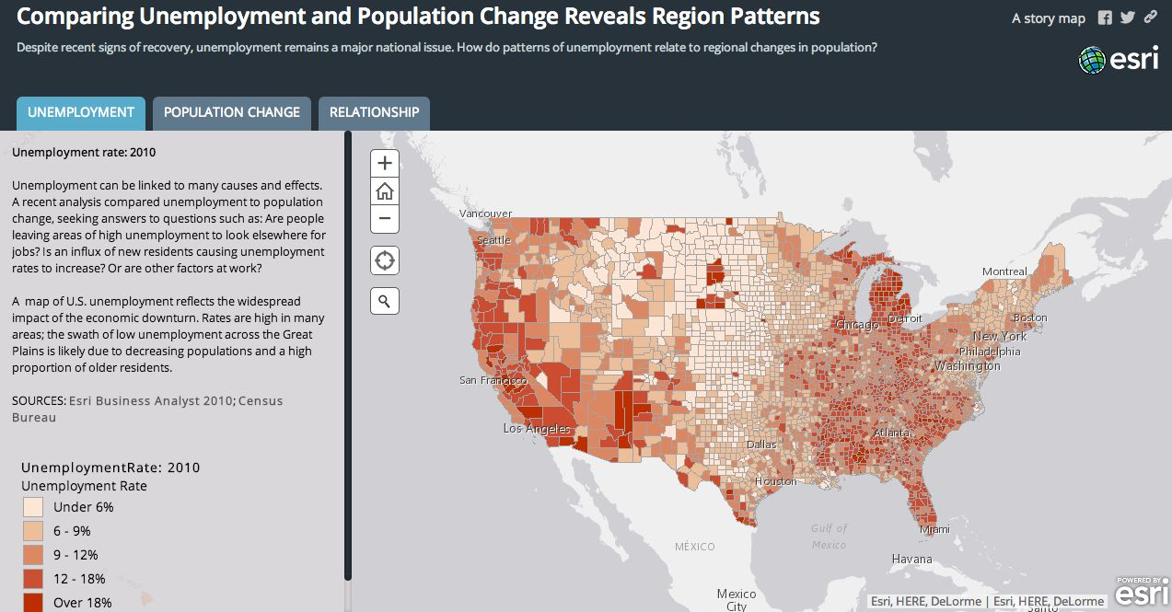

**Questions:**

Zoom to New York City and Long Island Area

Unemployement rate:

1. Is Suffolk county is better than Nassau?
2. Which is the worst county among all five counties of New York City?

Population Change:

1. Which county in the New York - New Jersey Area, the population has decreased the most?
2. How does Suffolk County compares with Nassau County?

<http://www.arcgis.com/apps/MapSeries/?appid=6aab740eb5f146d0bbc073185aa726cb>

**Elevation Profile:**

**http://tinyurl.com/dss-elev**

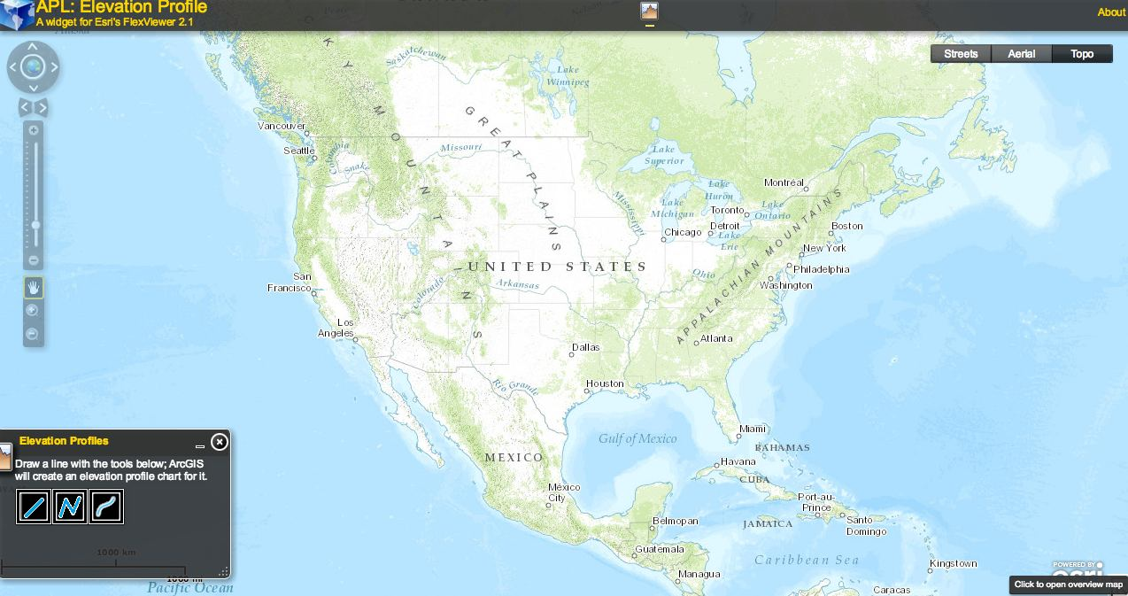

**Questions:**

Draw a line passing from San Fransisco through New York City.

1. Which State has the highest elevation point? Note down the altitude above sea-level?

Zoom to your School area in Long Island and vertical and horrizontal lines one after another to observe highest points in your school area.

1. Where will you suggest rescue centers in case of flooding?

<http://maps.esri.com/AGSFlex_Demos/FlexViewer21_viewItLive/index.html?config=cfg-ElevationProfile.xml>

__________________________________________________________________________

**Thanksgiving Dinner:**

**http://tinyurl.com/dss-thx**

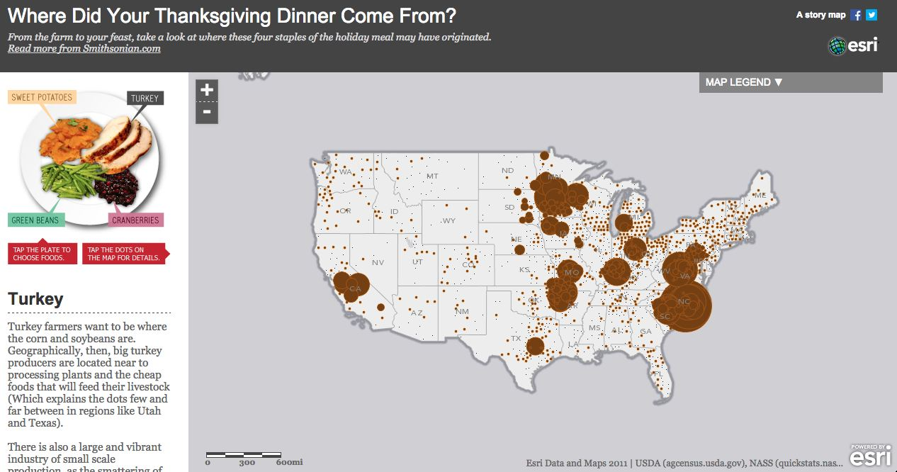

**Questions:**

1. Which State do you think the most Cranberries come from?
2. Zoom to that state and find out which county in that state has the largest farm for growing cranberries?
3. If you were to open a turkey sandwich shop, in which state would you locate your business? What other information you might need to help you make that decision?

[http://storymaps.esri.com/stories/2012/thanksgiving/#](http://storymaps.esri.com/stories/2012/thanksgiving/)

**Largest Malls:**

**http://tinyurl.com/dss-mall**

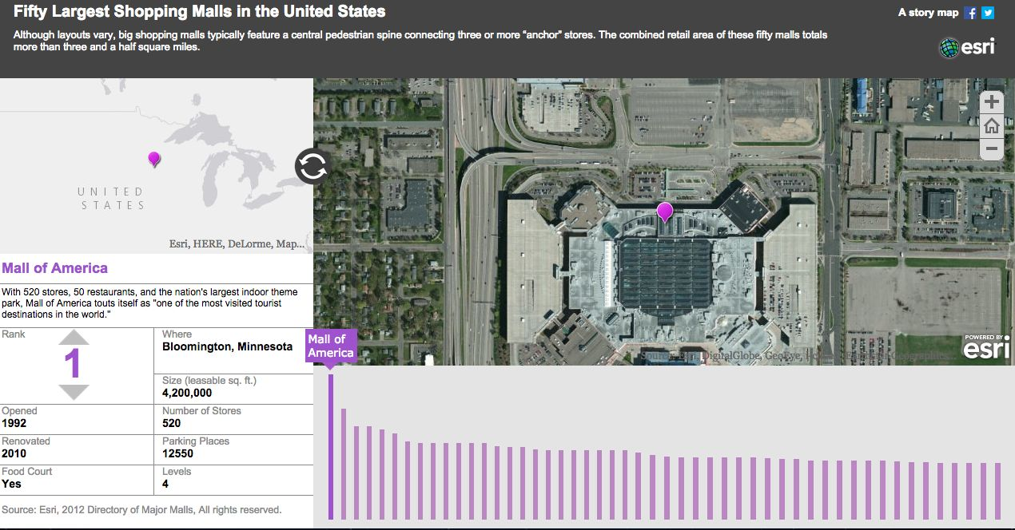

**Questions:**

1. How many of the 50 largest malls are located in New York State?
2. Which is the largest mall in New York State? How many shops are in that mall?

<http://storymaps.esri.com/stories/2012/malls/>

__________________________________________________________________________

**Change Matters - Viewer:**

<http://www.esri.com/software/landsat-imagery/viewer>

**Diabetes and Obesity**

<http://storymaps.esri.com/stories/diabetes/>

**A gallery of Amazing Species**

<http://storymaps.esri.com/stories/RedList/#overview>

**Highline walk**

<http://storymaps.esri.com/stories/highline/>

**Chicago**

<http://www.smithsonianmag.com/history/what-did-chicago-look-great-fire-180947929/>

**Volcanoes:**

<http://maps.esri.com/legends/Volcanoes_30/index.html>

__________________________________________________________________________



**Him Mistry**

Email: [himist@nyu.edu](mailto:himist@nyu.edu)

Email: [data.services@nyu.edu](mailto:data.services@nyu.edu)

Tel: 212-998-2427

**Stratos Efstathiadis**

Email: [stratos@nyu.edu](mailto:stratos@nyu.edu)

Tel: 212-998-3071

**Google Earth**

<http://www.google.com/earth/explore/products/desktop.html>

**Data Services:**

[What is GIS?](https://files.nyu.edu/hjm220/public/Tutorial%20Documentation/Fall%202012/ArcGIS%2010/Introduction%20to%20ArcGIS%2010%20Presentation.pdf) - Presentation