**Chapter 1- Kinematics Regents Physics**

**Intro to Kinematics**

**Kinematics** is the mathematical treatment of the motions of bodies without regard to the forces that produce the motion.

**Scalar Quantities vs. Vector Quantities**

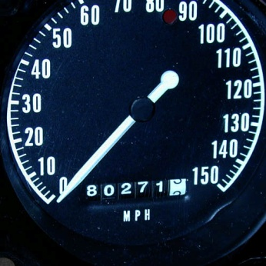A **scalar** quantity has magnitude but **not direction**. For example, the odometer in your family car tells you how fast the car is moving (magnitude or numerical value) but not the direction it is moving. Therefore, the odometer is telling you a **scalar** quantity (in this case: speed). For example, it tells you 45 mph, but **NOT** 45 mph East.

Here are some examples of **scalar** quantities:

Distance

Time

Speed

Mass

Temperature

Energy

A **vector** quantity has **both** magnitude and direction. For example, if you ask for directions to the beach in a foreign country, a citizen may tell you 50 km East. The citizen has given you both a magnitude (numerical value) and a direction (North, South, East, West, etc.)

Here are some examples of **vector** quantities:

Displacement

Acceleration

Force

Momentum

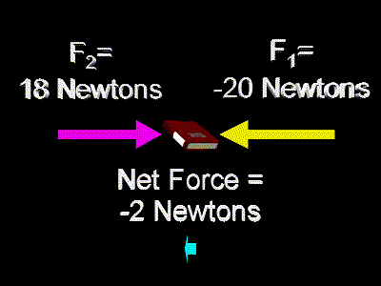Electric Force

Magnetic Force

**Practice: Determine whether the following are vectors or scalars.**

1. 40 m/s East
2. 30 m
3. 40o C
4. 20 kg(m/s) Northeast
5. 25 N
6. 25 N West
7. Distance
8. Displacement
9. Velocity
10. Speed
11. Momentum