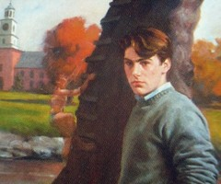  Gene Forrester | The Narrator of the book. Student at Devon school during World War II  His best friend is Phineas (superior athlete). Gene is known for his academic skills
Phineas (Finny)  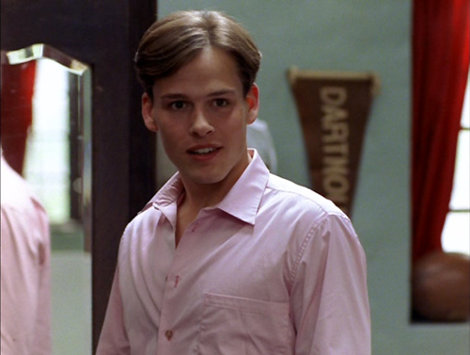 | Gene’s best friend and roommate. He is a remarkable athlete with a disregard for the rules and an ability to win over people. He’s social and funny.
Leper Lepellier  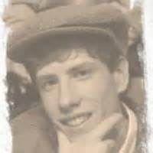 | A soft-spoken, nature loving boy, with an old soul. He is a little odd compared to the other boys. He is an avid skier and naturalist.
Mr. Ludsbury
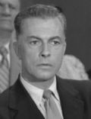

Quackenbush
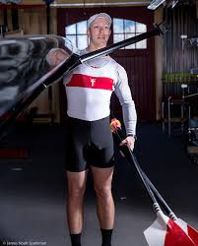

Mr. Prud’Homme


Brinker
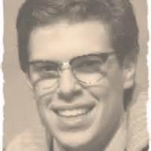

Mr. and Mrs. Patch-Withers | Other Substitute Teachers whom Finny describes as “Stern” (Strict) and “conventional” (unimaginative).
Phil Latham
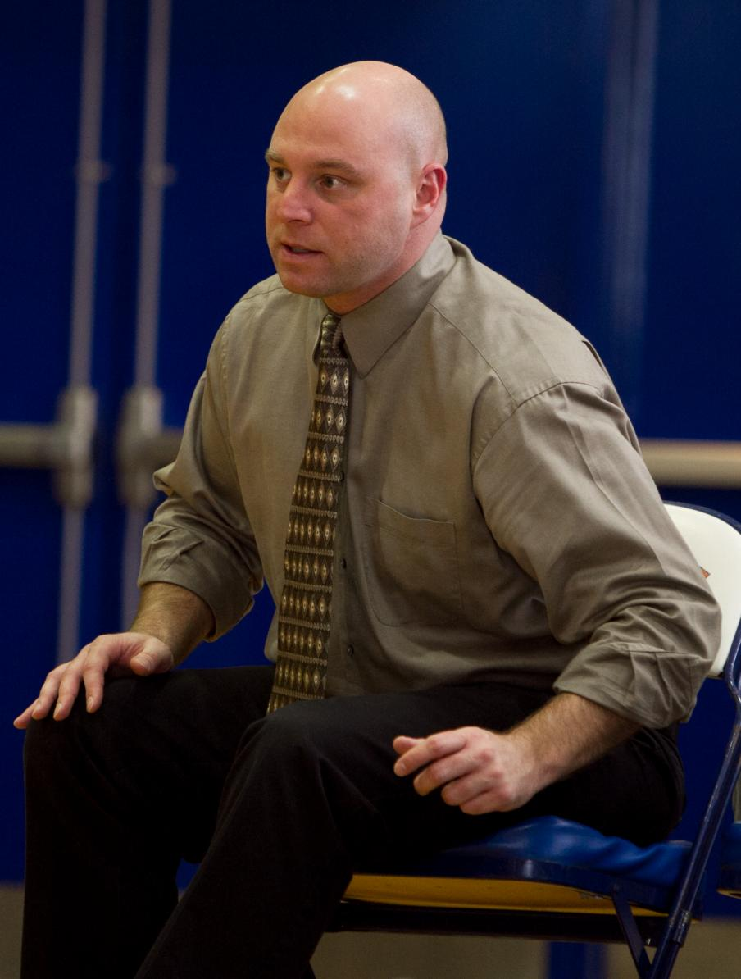
Bobby Zane
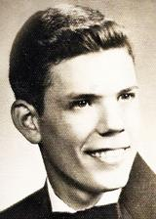
Brinker Hadley
Brownie Perkins
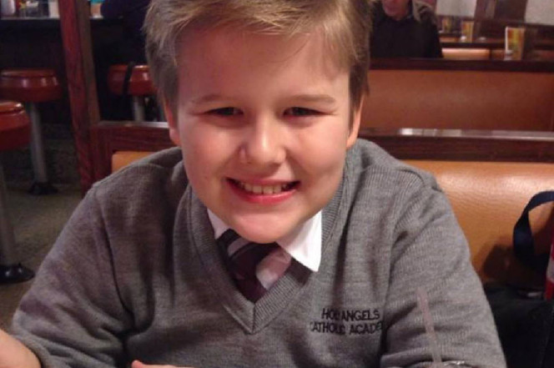
Captain Marvel

Chet Douglass

