Big Bang Theory | The belief that the Universe began from an explosion of a very dense atom. | 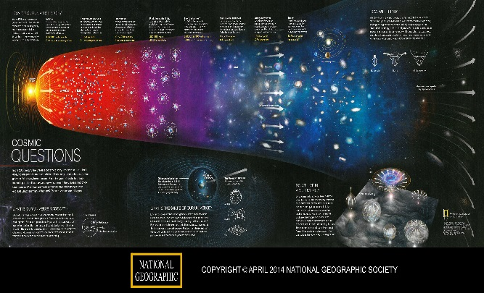  *Universe is still expanding
Galaxies | Collection of solar systems and stars | 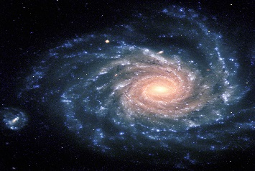  We live in the Milky Way Galaxy
Doppler Effect | An increase (or decrease) in waves, of an observer moving towards or away from an object | 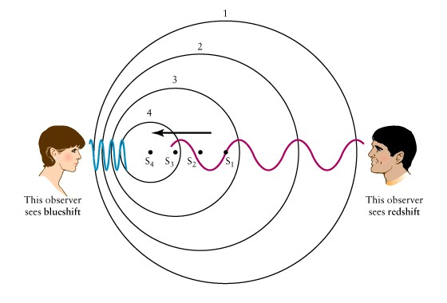  red shift-moving away  blue shift-moving towards
Stars | Source of energy for solar systems  -various types (ESRT pg. 15) | 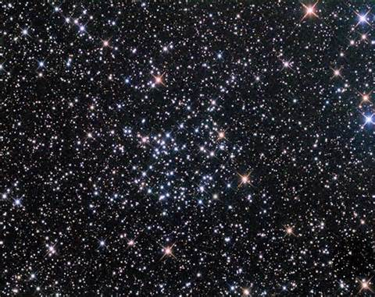
EM Spectrum | Electromagnetic spectrum is the range of all the possible frequencies of radiation. | 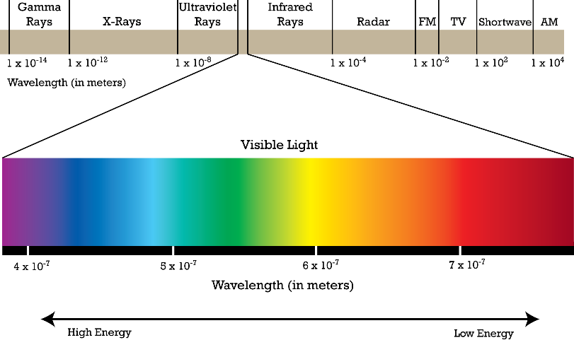
Solar System | Collection of planets around a star | 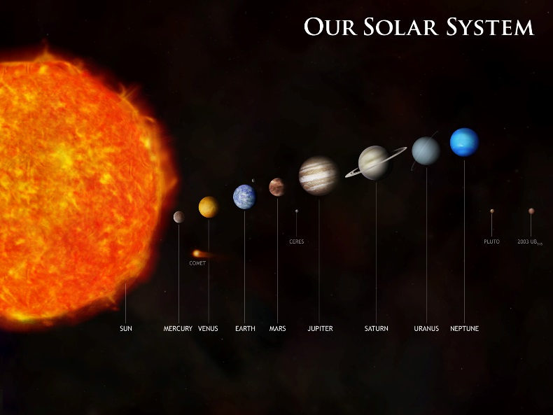
Terrestrial Planets | -Planets with land/rock  -Terrain | 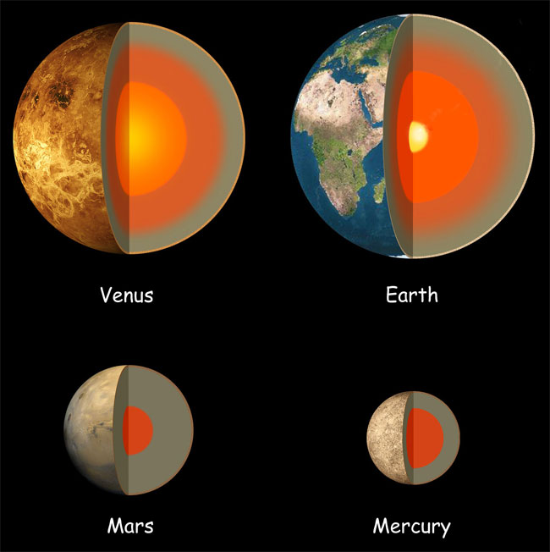
Jovian Planet | Gaseous Planets | 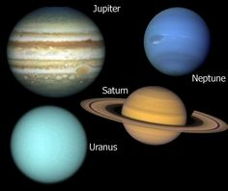
Planetary Rotation | The amount of time a planet takes to spin and make one day. | 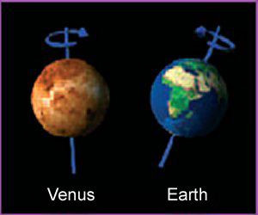
Planetary Revolution | The amount of time it takes for a planet to move around a star/sun | 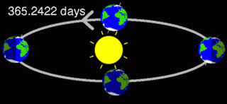
Ellipse | an ellipse is a curve on a plane surrounding two focal points | 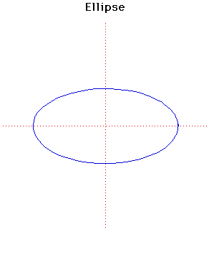
Eccentricity | The measure of how circular or oval an orbit is. | 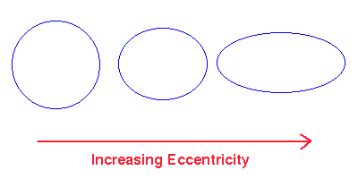
Inertia | The resistance of an object to stay in motion. | 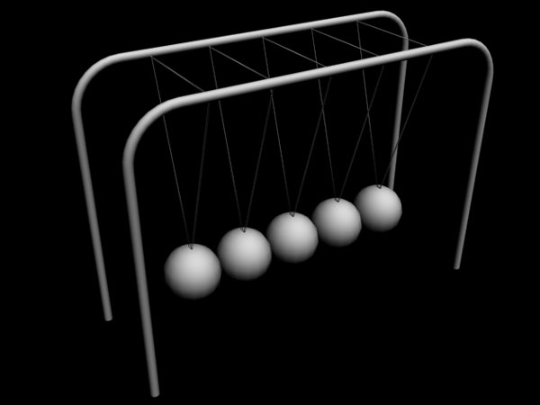
Gravity | A force that pulls to the center of it’s mass. | 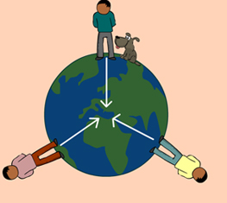
Kepler’s Laws of Planetary Motion | Laws that describe planetary motion. | 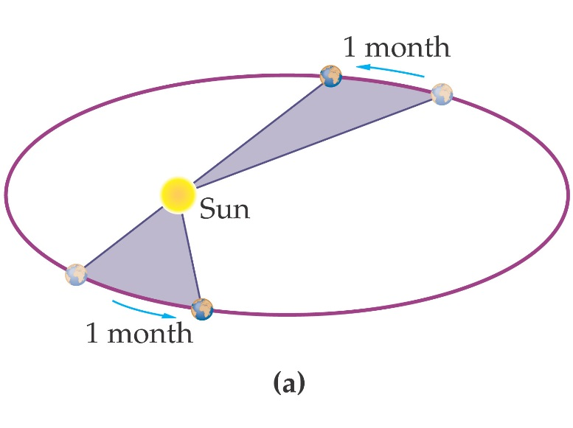  Law of Equal Areas

