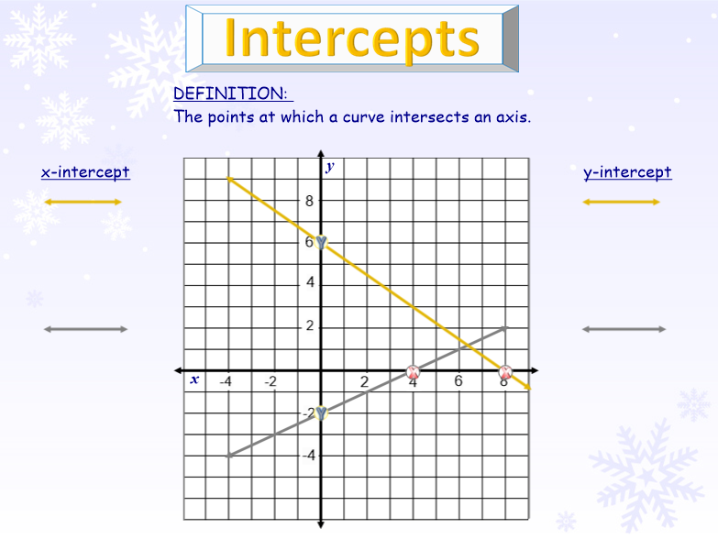 https://drive.google.com/file/d/0B33fCC6GOGAUMWlNTmN6RmxmNG8/view?usp=sharing 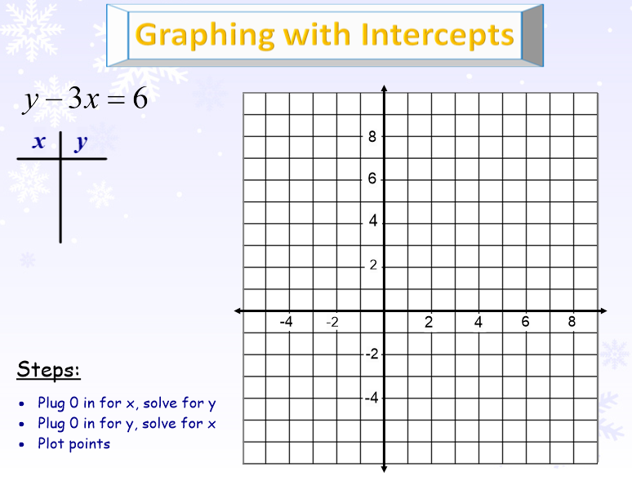

Identify the location (coordinates) of the x- and y-intercepts for each graph.

|  |  |  |  |
| --- | --- | --- | --- |
| 1)  x-intercept  y-intercept |  | 2)  x-intercept  y-intercept |  |
| 3)  x-intercept  y-intercept |  | 4)  x-intercept  y-intercept |  |

Find the x- and y-intercepts and use to graph the following linear equations.

