Term | Definition
Adobe  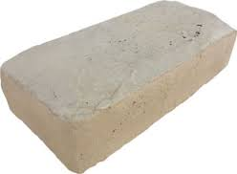 | Sun dried brick used for building
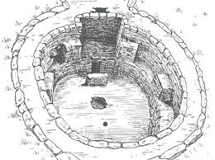  Kiva | Underground religious chamber
Potlatch  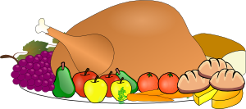 | Feast that is meant to show the wealth of a host
League of Iroquois   | 5 tribes united to achieve peace
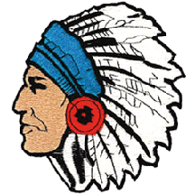  Sachem | Tribal chief
Kayak  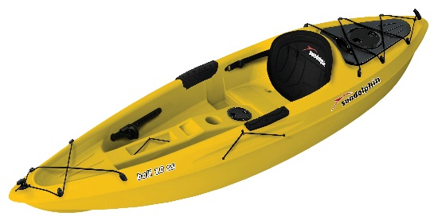 | Small boat made from skins
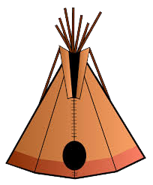  Tee Pee | Triangular tent made from animal skins
Wig Wam  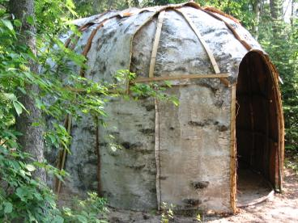 | Circular dwelling made from tree bark
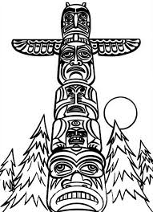  Totem Poles | Wood carved animal spirits
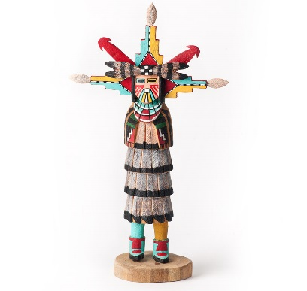  Kachina | A doll made to honor spirits
SS 7 Quiz #3 Review

People to Know:
Person | Importance
Wilma Mankiller | Became the chief of the Cherokee tribe
  Hiawatha | Was a great orator (speaker) of the Iroquois
Peacemaker | A prophet of the Iroquois that created the Great Law of Peace
  Ben Nighthorse Campbell | He was the first Native American to become a United States Senator
Native Americans – how many are there in America today?? | 2 million

