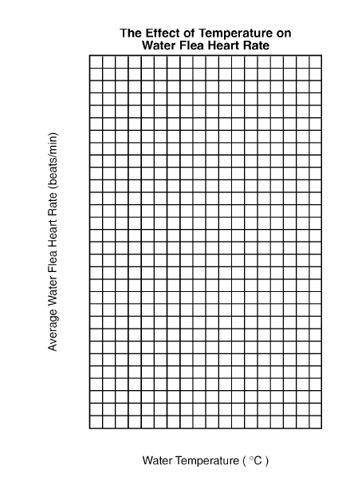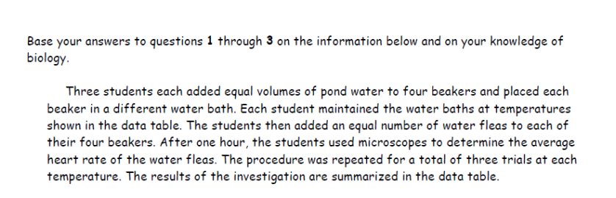Name ____________________________

|  |  |
| --- | --- |
| Water Temperature  (Degrees C) | Average Water Flea Heart Rate  (beats/min) |
| 5 | 40 |
| 10 | 85 |
| 15 | 119 |
| 20 | 166 |
| 25 | 205 |
| 30 | 245 |
| 35 | 280 |

