[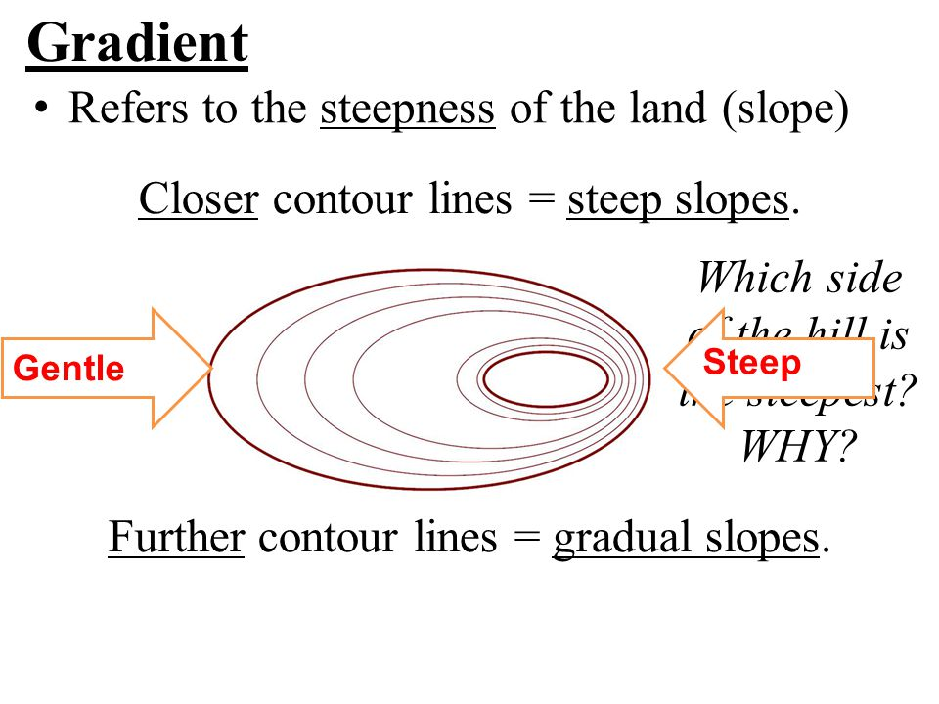](http://www.google.com/url?sa=i&rct=j&q=&esrc=s&source=images&cd=&cad=rja&uact=8&ved=0ahUKEwjyiYyJh9jPAhXCLyYKHWMPAYIQjRwIBw&url=http%3A%2F%2Fslideplayer.com%2Fslide%2F5282711%2F&psig=AFQjCNH9Aa_Lb6Fn-80sB0hL_x3ZB9hVGw&ust=1476457524882383)

[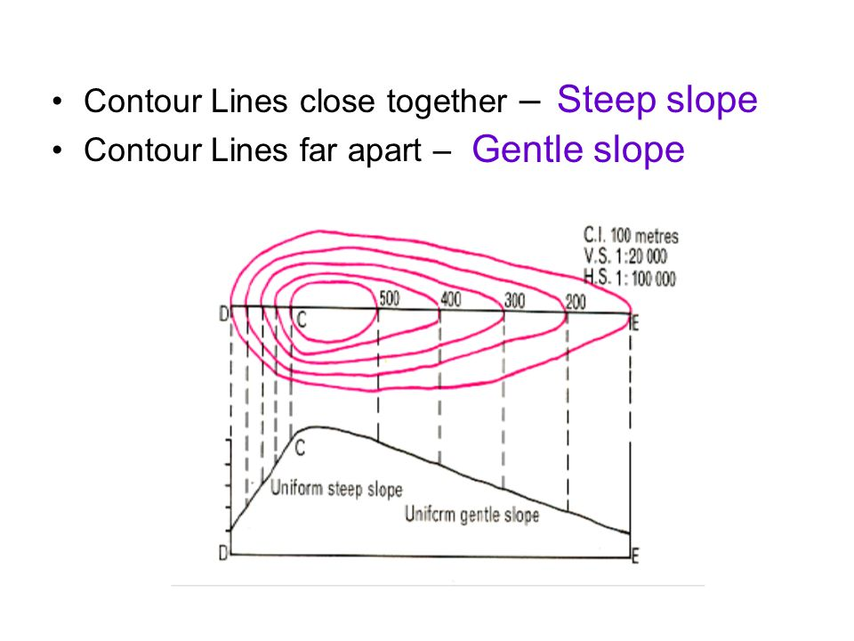](http://www.google.com/url?sa=i&rct=j&q=&esrc=s&source=images&cd=&ved=0ahUKEwjyiYyJh9jPAhXCLyYKHWMPAYIQjRwIBw&url=http%3A%2F%2Fslideplayer.com%2Fslide%2F4751523%2F&psig=AFQjCNH9Aa_Lb6Fn-80sB0hL_x3ZB9hVGw&ust=1476457524882383)

[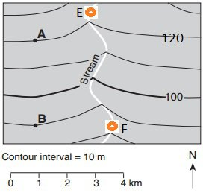](http://www.google.com/url?sa=i&rct=j&q=&esrc=s&source=images&cd=&cad=rja&uact=8&ved=0ahUKEwiDpZuhiNjPAhVEKCYKHXqZCuYQjRwIBw&url=http%3A%2F%2Ftimclauss.wixsite.com%2Fearthscience%2F21-topographic-mapping&psig=AFQjCNH9Aa_Lb6Fn-80sB0hL_x3ZB9hVGw&ust=1476457524882383)

What direction does the stream flow?

1. North
2. South
3. It doesn’t flow

HOW DO YOU KNOW?

______________________________________________________________________________________________________________________________________

FIND THE GRADIENT

[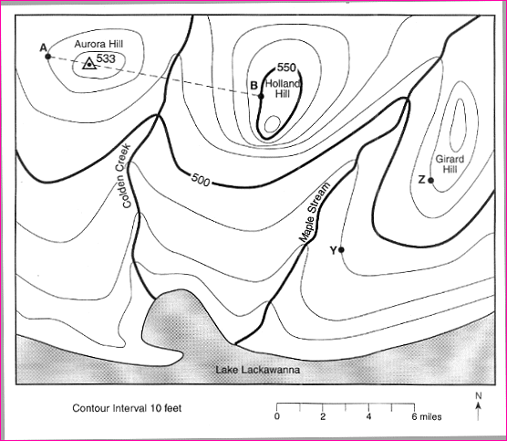](http://www.google.com/url?sa=i&rct=j&q=&esrc=s&source=images&cd=&cad=rja&uact=8&ved=0ahUKEwi7nIDiidjPAhUGSSYKHWIHCf8QjRwIBw&url=http%3A%2F%2Fwww.edusolution.com%2Fedusolution2%2Fearthsci%2Fjune2003%2Fpage11.htm&bvm=bv.135475266,d.eWE&psig=AFQjCNGB_SV0dQaTY1M1orbCPlJhn3LQaQ&ust=1476457946693129)STEP 1: Write the formula

STEP 2: Substitute Numbers

STEP 3: Solve using Math

Answer with labeled Numbers

_______________________

Draw the Topographic Profile

