The New Deal, Alphabet Agencies and Acts
AAA: | Agriculture Adjustment Act | Paid farmers to produce crops and taught soil erosion prevention methods
CCC: | Civilians Conservation Corps | A work and relief program that sent young, unemployed men to work on conservation projects in rural areas for $1 per day.
CWA | Civil Works Administration | Provided public works jobs at $15/week to four million workers in 1934.
EBA | Emergency Banking Act | This act gave the executive branch to right to regulate banks
NRA | National Recovery Administration | Authorized the president to regulate industry and to raise wages and prices.
FDIC | Federal Deposit Insurance Corporation | Insured deposits in bank accounts; the FDIC currently guarantees checking and savings deposits in member banks up to $100,000 per depositor.
FERA | Federal Emergency Relief Administration | Provided “relief” to the needy. FERA provided state assistance for the unemployed and their families
FLSA | Fair Labor Standard Act | Established a minimum wage and a 40-hour work week.
FSA: | Farming Security Administration | Brought farmers together to work on large government-owned farms using modern techniques; Provided loans for farmers to buy land
PWA | Public Works Administration | Received $3.3 billion appropriation from Congress for public works projects.
SEC | Securities and Exchange Commission | An agency of the U.S. government that regulates transactions in securities (stocks and bonds) to protect investors against malpractice.
SSA | Social Security Act | Provided pensions, unemployment insurance, and aid to blind, deaf, disabled, and dependent children.
TVA | Tennessee Valley Authority | Build dams, provided electricity, and bought modern farming methods to the Tennessee River Valley, a poor and region of the U.S. at that time.
WPA | Works Progress Administration | Employed 8.5 million workers in construction and other jobs; provided work in arts, theater, and literary projects.

Directions: The New Deal introduced government agencies to address the problems that Americans faced. You will investigate one agency and then create a poster that explains the agency’s role to the American people. Study the actual posters from the 1930’s are available in class to look at before you produce your own.

Materials: Books, the Internet, colored pencils, poster,” drawing paper.
Your design will be graded on the following criteria:

Grading Rubric and Requirements:
Your Poster Will...
- Show its agency’s work and how the public benefits from the agency to solve the problems of the depression.
- Advertise and win public support for the agency.
- Be neatly and creatively completed
- Include a 1-paragraph explanation about your agency and poster. (Paraphrase information if you take information from websites or books.) *This part will be completed in school but may need to be taken home.

Paragraph 1: State the year the agency was founded, its main purpose and, and if it was created by FDR in an “executive order” or enacted by congress. State if this agency is still around today? In not, when did it cease and why? *You will need to research this.

Paragraph 1: Explain “who” the workers were, where (the state/region) they worked, and the specific type of work they performed, training they received, and how much they were paid. Include information of how many people worked in this agency if available. *Include a photograph of the workers.

Paragraph 1: Describe your poster, the designs and colors you used, and how it represents the agency that you studied. How does your poster depict your agency and its work? If there are words on your poster, explain them.

Websites to find more information about the New Deal alphabet agencies:

http://www.authentichistory.com/1930s.html#images
- http://memory.loc.gov/ammem/wpaposters/wpahome.html
- http://en.wikipedia.org/wiki/Alphabet_agencies
- http://newdeal.feri.org/library/index.htm
- http://www.bergen.org/AAST/projects/depression/successes.html

Fireside Chat Lesson Names ___________________________________

FDR Memorial in DC

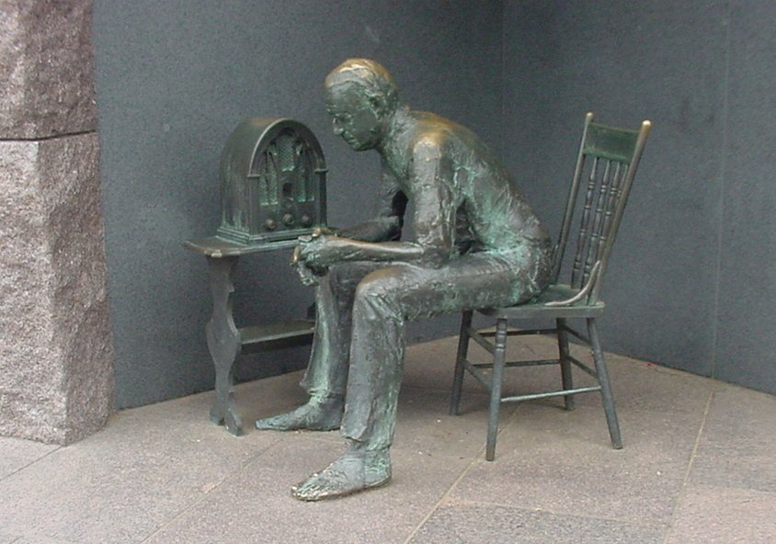
Fireside Chat Activity

Assignment:
In a group of two or more, you will write a Fireside Chat, and perform it to the class. Your job is to explain the new program and sell the idea, gaining support from the American public. Bring simple props to school when you perform your chat.

Web Help:
For the real Fireside Chat transcripts see: http://www.fdrlibrary.marist.edu/firesi90.html To learn about the different agencies see: http://en.wikipedia.org/wiki/Alphabet_agencies

Topics to choose from: Banking Relief, Farms Programs, Regulating Wall Street, Labor Issues, Unemployment, Social Security, Relief proposals, Programs for the Young (CCC), the Dust Bowl and Drought.

Requirements/Rubric: Fireside Chat -50 Points

- A full explanation of the program. –10 points
- A description of “who” the program will benefit. –10 points
- An appeal for the support of the American People. –10 points
- Be persuasive in both your writing and speaking. –10 points
- Speak clearly and convincingly. –10 points

