**Chapter 1- Kinematics Regents Physics**

**One-Dimensional Motion – Constant Acceleration Equations**

As we already know, acceleration is defined as the change of velocity per unit of time and can be found using:

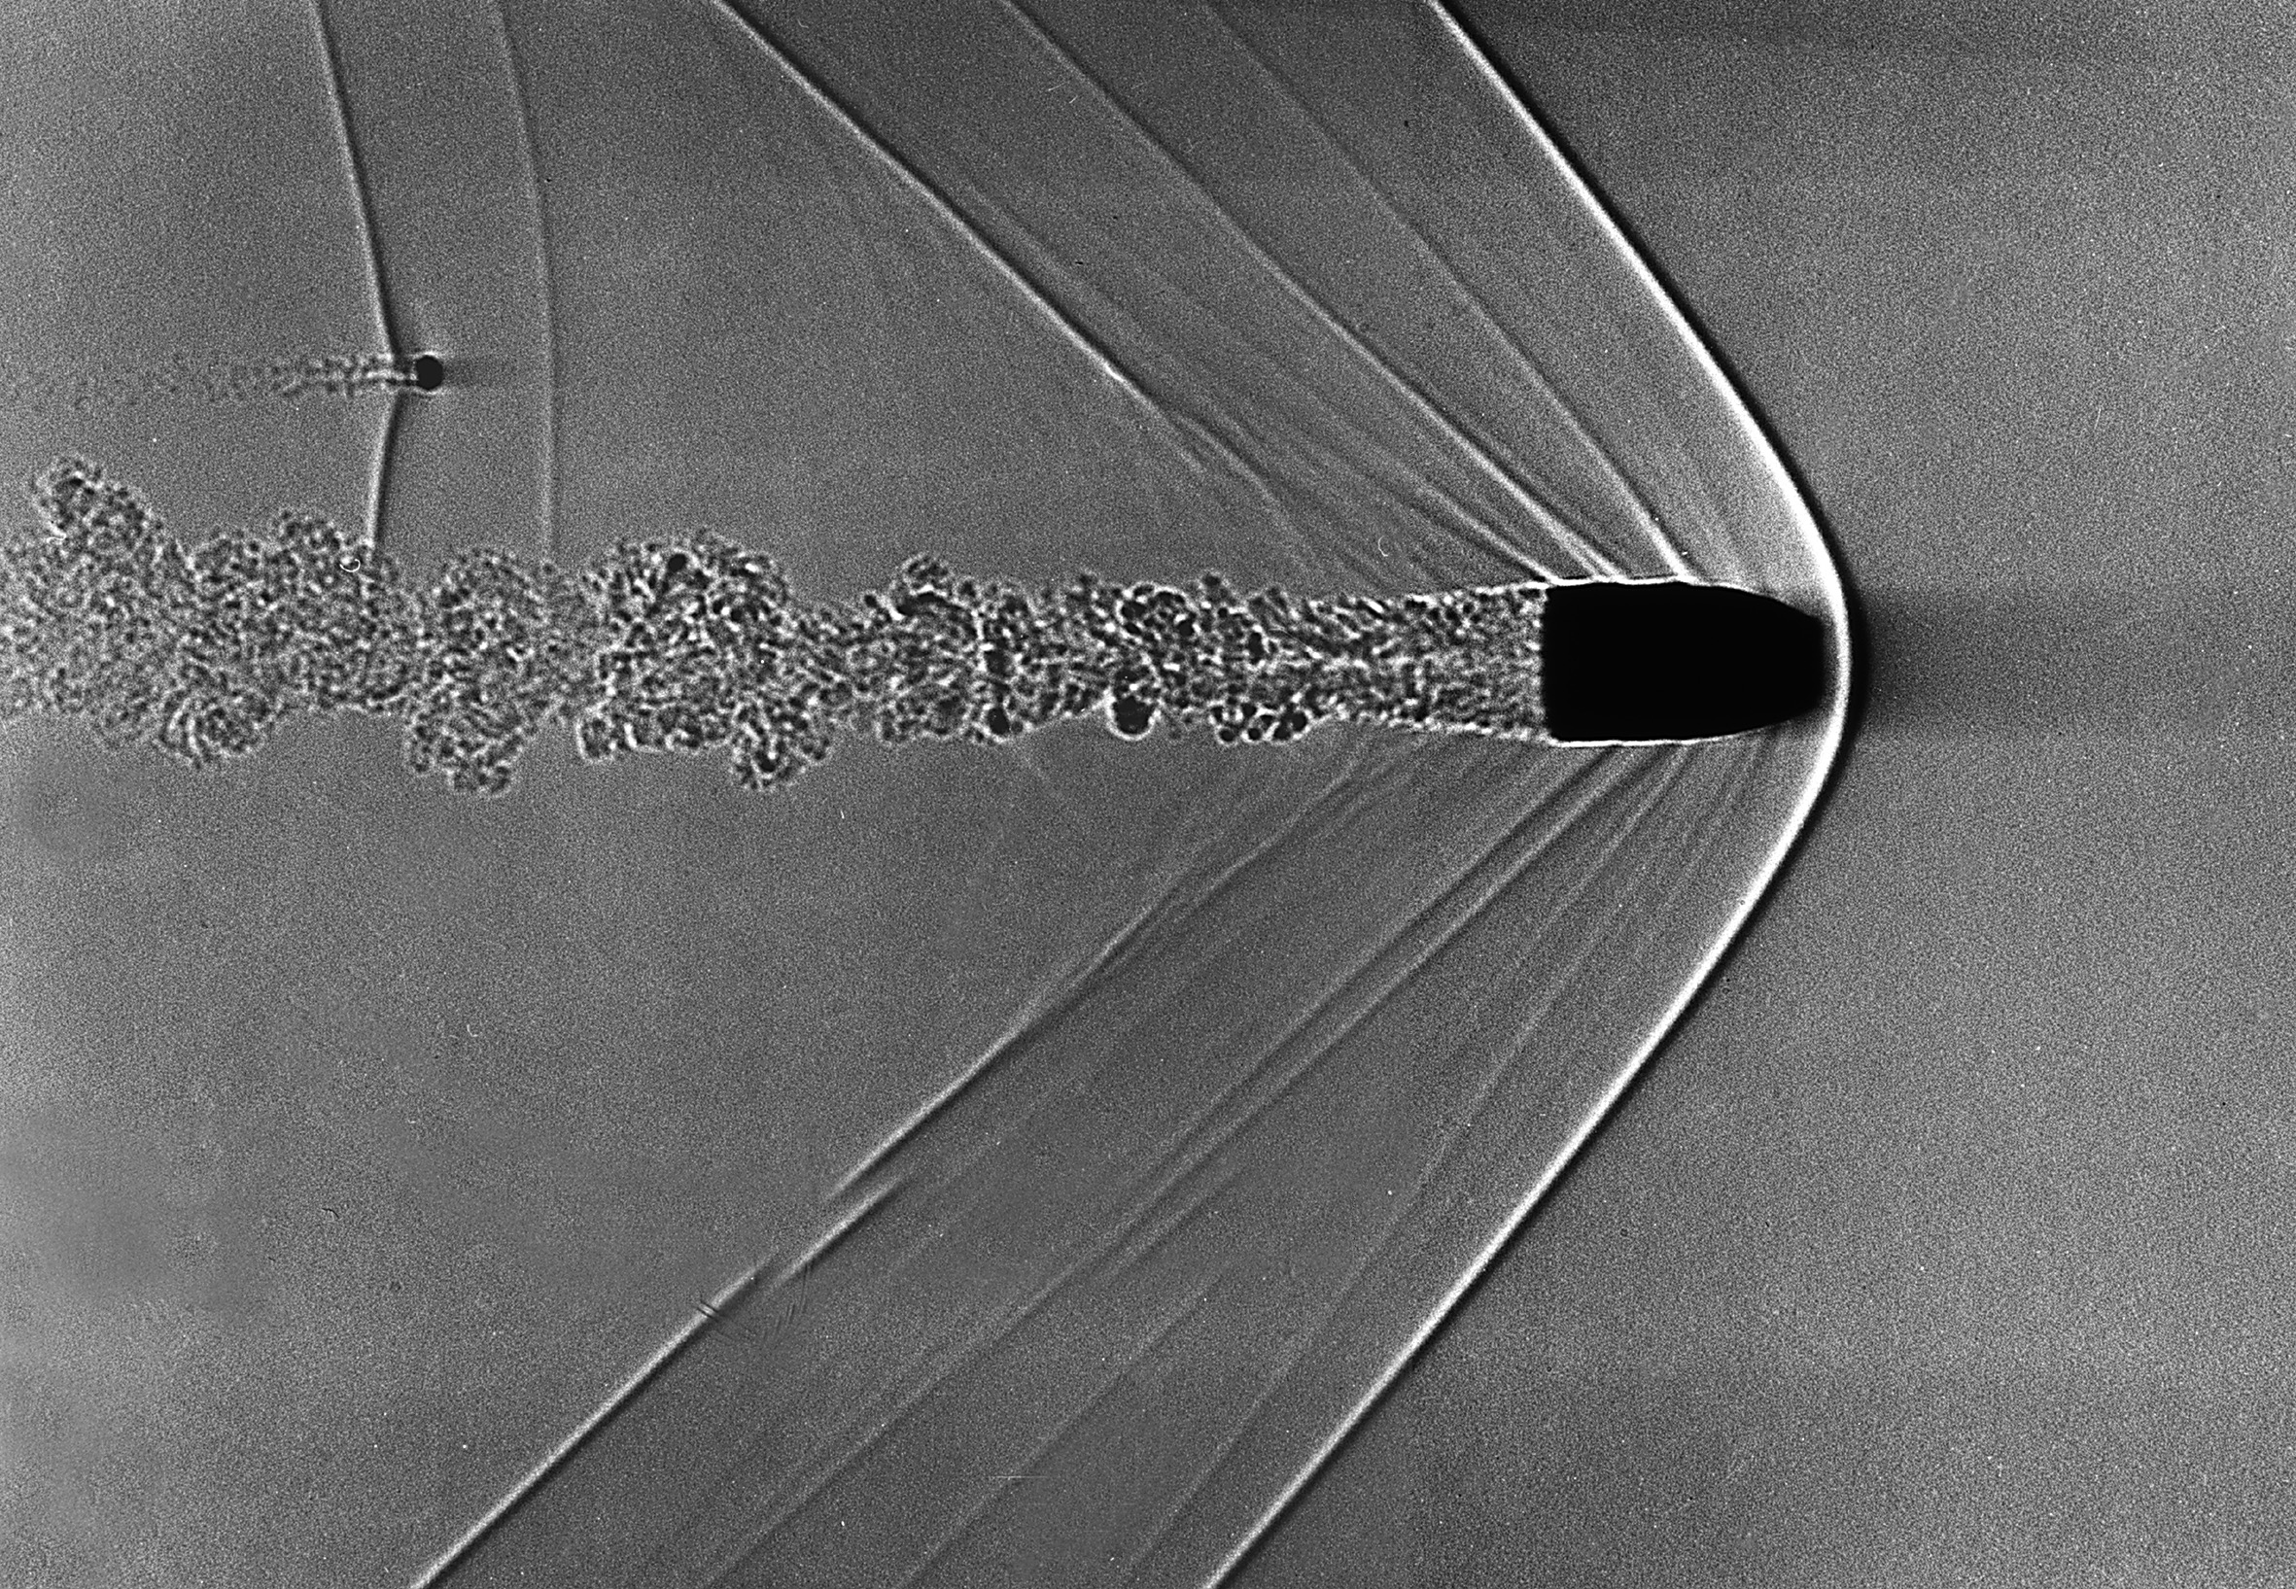Since: *vf - vi,* our formula then becomes:

If we apply some algebra and solve for “*vf*” then we arrive at:

**vf = vi + at**

Several derivations using the above information lead to useful equations when we want knowledge of an object’s displacement, velocity, or acceleration at any particular time. Such equations include:

**d = vit + at2**

**vf2 = vi2 + 2ad**

Knowing which equation to use relies simply on the information **you are given** in the problem. In other words, it is important to write down **every** piece of information given by the problem including the variable that **you are looking for**.

**For example:**

1. Roger starts from **rest** and accelerates at 4 m/s2 for 3 seconds. How **far** has Roger travelled?

Notice how if an object starts from **rest**, vi (initial velocity) will **always be zero.** Similarly, if an object **comes to rest**, the vf (final velocity) will be zero.

1. A bowling ball moving 20 m/s comes to rest at the end of the alley 20 meters away. Determine the acceleration of the bowling ball.
2. A soccer ball kicked from rest travels 50 meters in 3 seconds. Determine the acceleration of the soccer ball.
3. A car is initially moving at 20 m/s. The car then accelerates at a rate of 5 m/s2. How fast will the car be moving after 400 meters?
4. Superman is flying at 300 m/s. He then accelerates at a rate of 20 m/s2 for 10 seconds. How fast is he now flying?