Name____________________

Geometry Common Core: Review Lesson 1-6A

1. 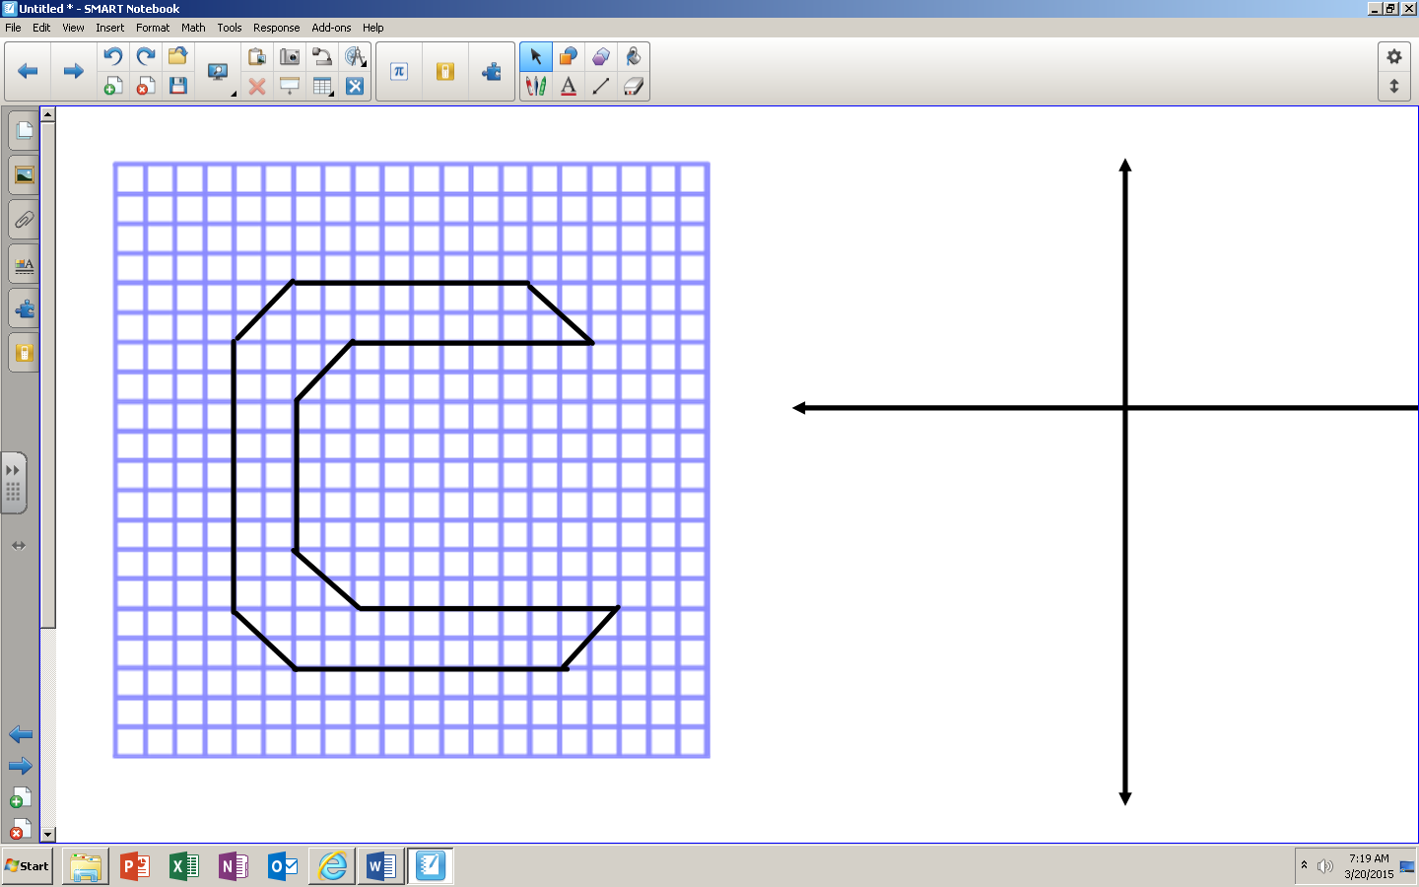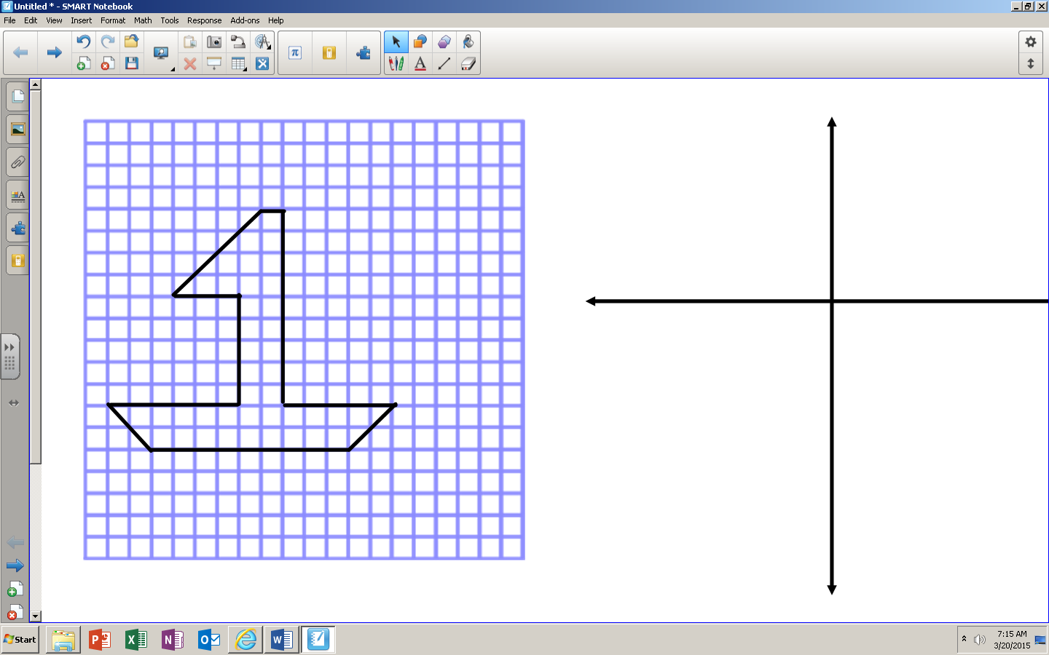Find the area by counting the number of squares and triangles in the pictures below:  
   a) b)

1. 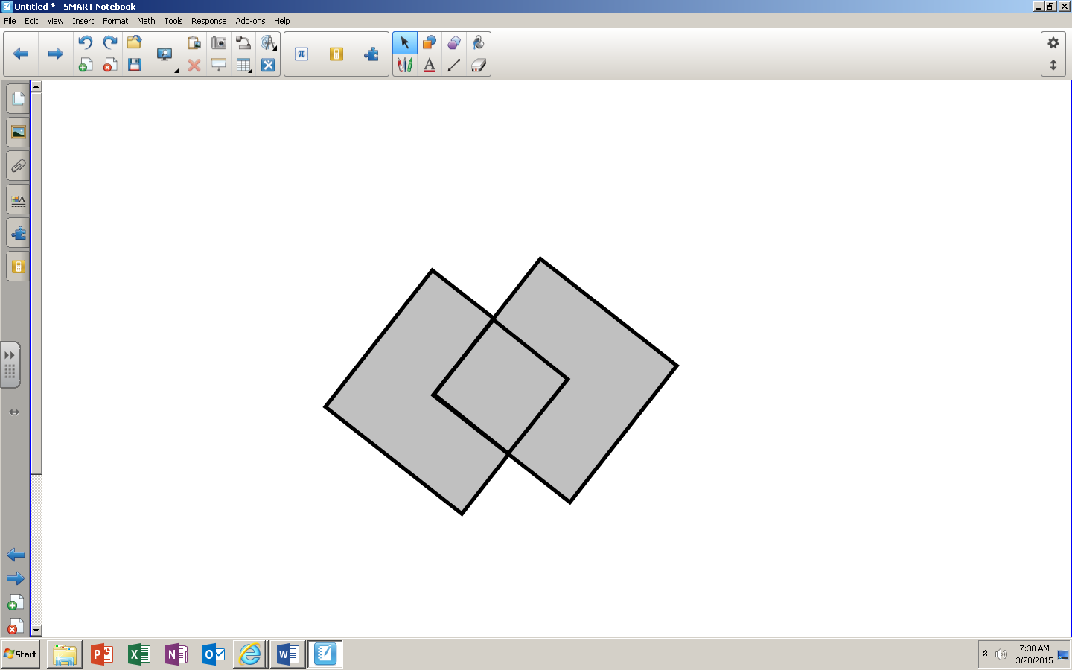Two squares with 8-inch sides overlap at their midpoints. Find the shaded area.
2. 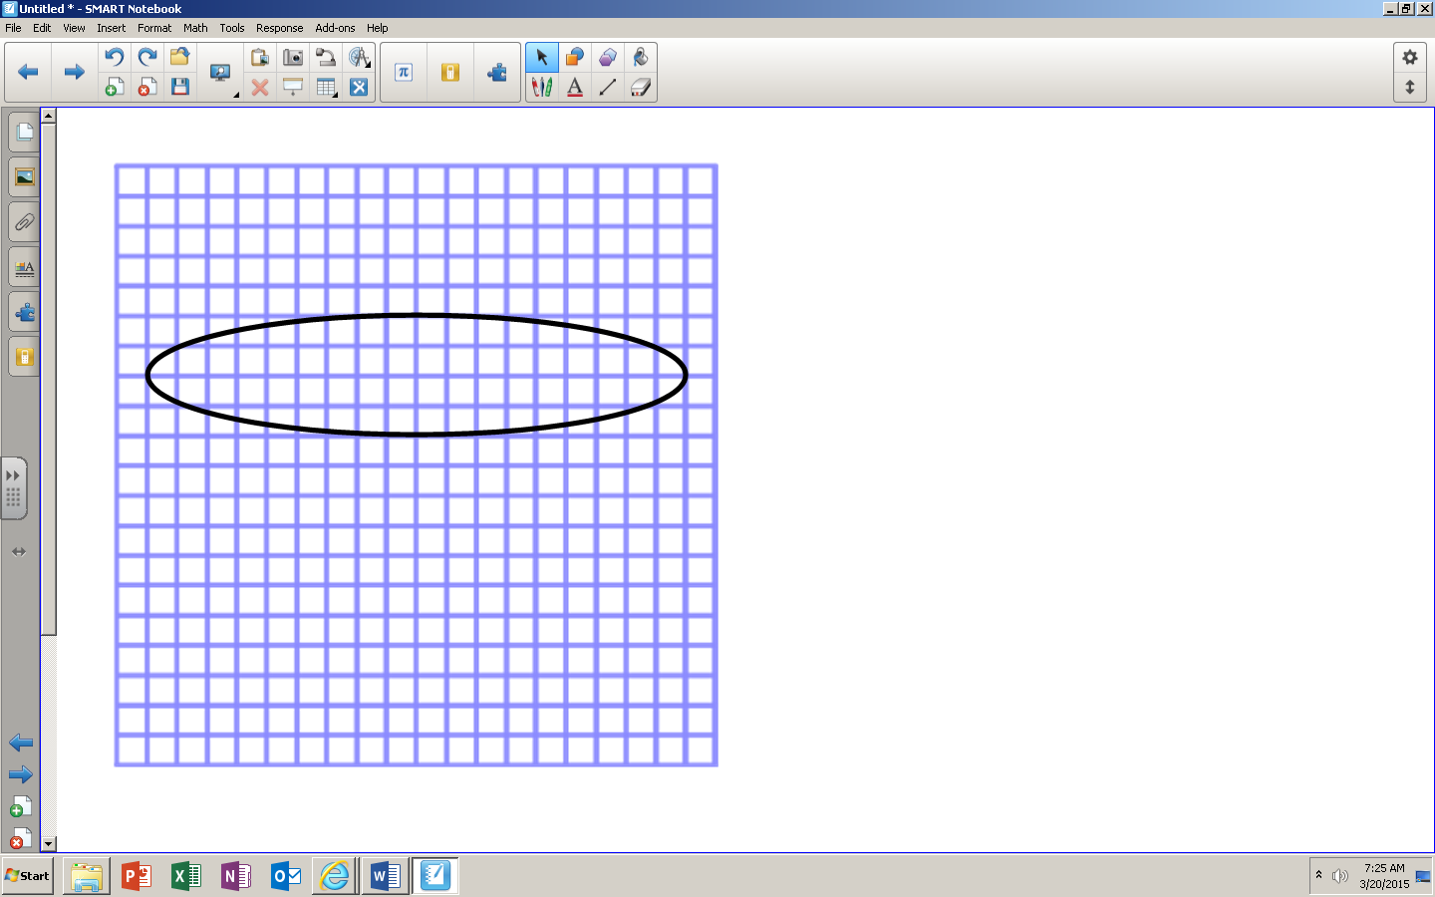a) Find the **lower** estimate of the area of the figure to the right:  
     
     
     
     
     
     
     
     
   b) Find the **upper** estimate of the area of the figure to the right:  
     
     
     
     
     
     
     
     
     
   c) Find the average estimate of the area of the figure to the right:  
     
     
     
     
   d) If the actual area is 18 units2, what is the perecent error using your calculation from part c to the nearest hundredth.
3. 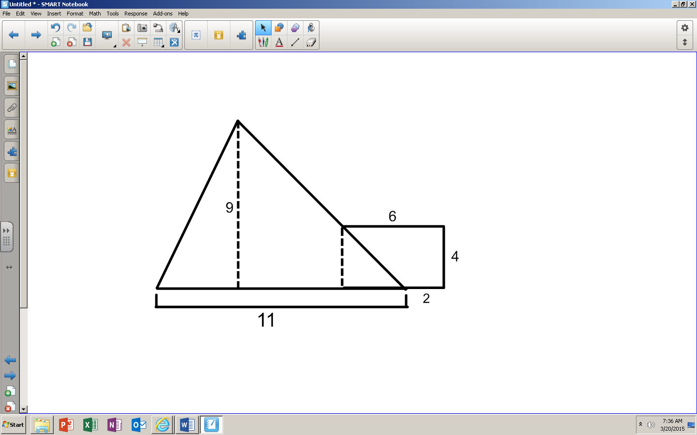Find the area of the combined shape:
4. 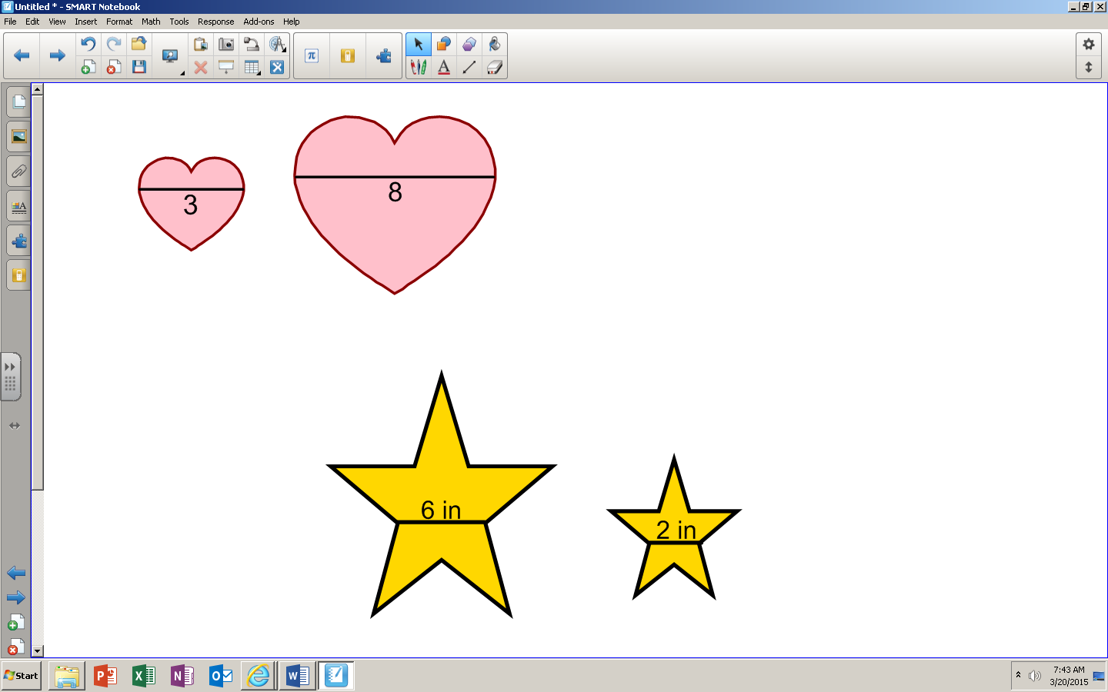Find the ratio of the areas of each pair of corresponding similar figures. The lengths of the corresponding line segments are shown.  
   a) b)   
   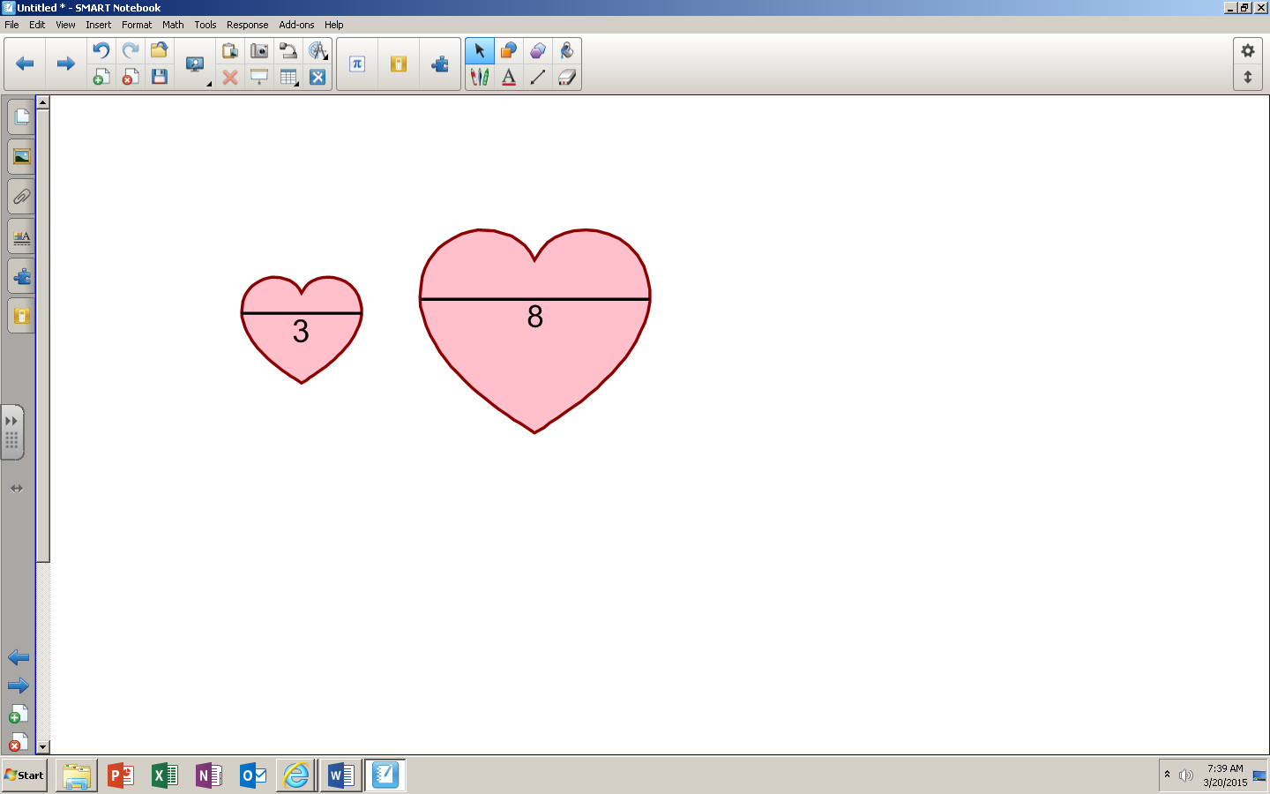

1. The lengths of the corresponding line segments are shown. If the area of the smaller figure is 4 cm2 what is the area of the larger figure to the nearest tenth?  
   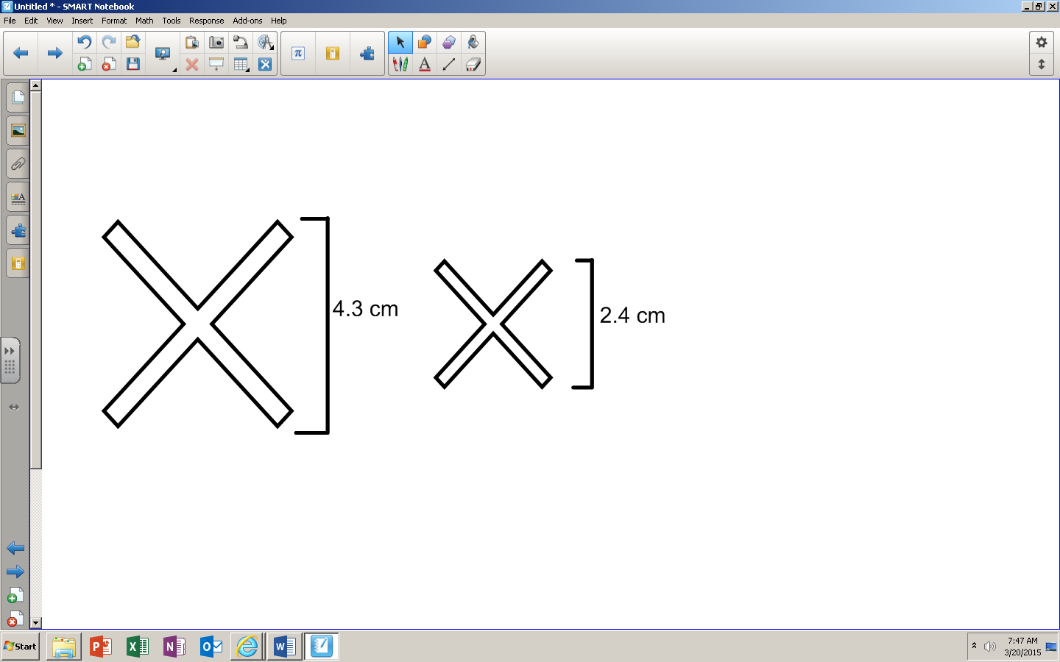
2. The large star has an area of 8 mm2. The small star is obtained from the large star by stretching by a factor of in the horizontal direction and by a factor of in the vertical direction. Find the area of the small star.

1. Find the circumference of a circle with a radius of 3 cm in terms of .
2. 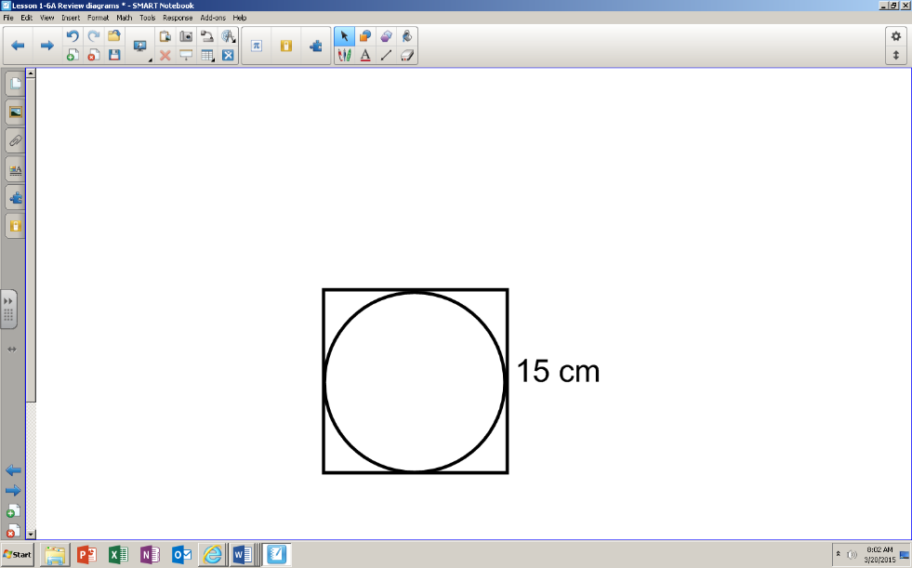What is the circumference of the circle inscribed in the square to the right in terms of .?
3. If the circumference is 8 inches, what is the length of the radius to the nearest tenth of an inch?

1. 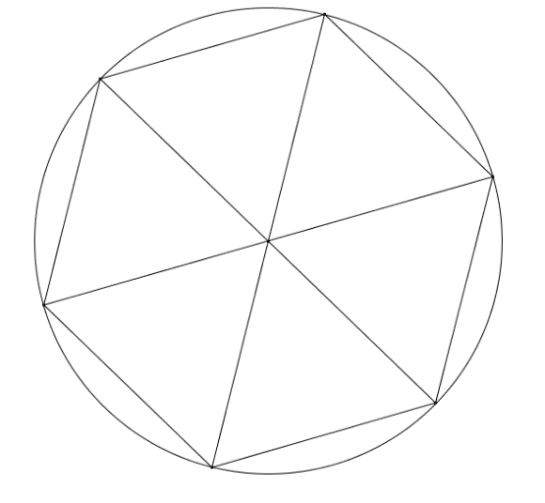a) Approximate the area of a disk of radius inches using an inscribed regular hexagon in simplest radical form.

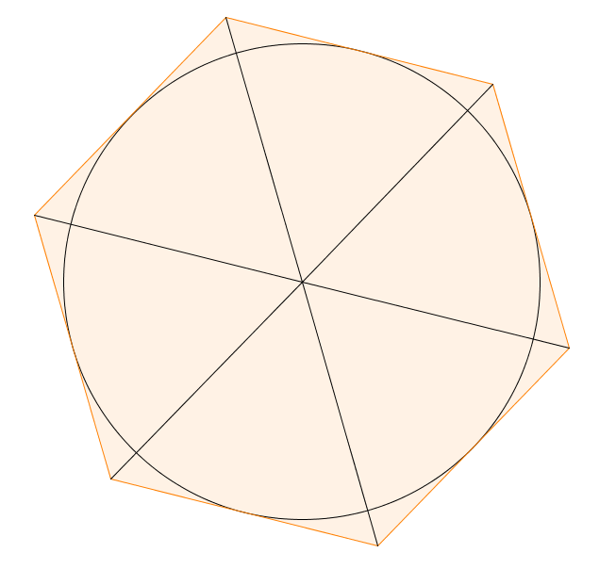

b) Approximate the area of a disk of radius inches using a circumscribed regular hexagon in simplest radical form.

c) Calculate the average area using your upper and lower estimates in simplest radical form.  
  
  
d) Calculate the actual area of the circle in terms of .

e) Find the percent error in your calculation to the nearest tenth.

1.  If the perimeter of a square is 44 inches and the circumference of a circle is also 44 inches.   
   a) Find the area of each of the two shapes.  
     
     
     
     
     
     
     
     
     
     
     
   b) Which shape has a smaller area?

For questions 13-15, use the right hexagonal prism:

1. What can be concluded about points A, B, and C?
2. For each pair of lines below, are they parallel, skew, or do they intersect?  
   a) BC and F’E’  
     
   b) D’D and AB  
     
   c) A’B’ and D’C’
3. Name two planes that are parallel.
4. Name two planes that are perpendicular.
5. [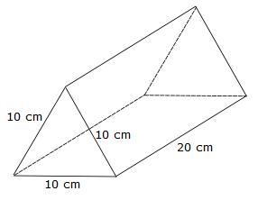](http://www.google.com/url?sa=i&rct=j&q=equilateral+triangular+prism&source=images&cd=&cad=rja&docid=f8BD0IcIfJvGgM&tbnid=IuFhpJ_dXSuAsM:&ved=0CAUQjRw&url=http://chatfer2011.wordpress.com/2011/04/27/area-of-a-rectangular-prism/&ei=ySMzUuXBIJHu9ATkuIDQAQ&bvm=bv.52164340,d.eWU&psig=AFQjCNHlbeJeDnOo3B39cCFUhcwORNdIRQ&ust=1379169598633945)How much soup can you put into a can with a diameter of 2 inches and a height of 6 inches, keep your answer ***in terms of π***?
6. If I have a triangular prism with an equilateral triangle base as shown below, what is the volume of the prism ***in simplest radical form***?

**30 mm**

**12 mm**

1. Find the shaded area of the figure below ***to the nearest tenth***: [4 points]