**Name:________________________________ Regents Physics**

**Chapter 7- Momentum**

**Momentum**

The **momentum (p)** of an object is simply its mass **multiplied by its velocity**. Therefore, the equation is:

**p = mv**

Mass (m) is in kilograms, velocity (v) is in meters per second, and momentum (p) is in kg.m/s. Momentum is a **vector** quantity. The direction of a momentum vector is **the same as the direction** of the velocity.

**If an object is not moving (v=0 m/s), it has ZERO momentum!**

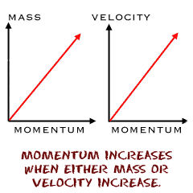

**For Example:**

1.) What has more momentum: an 18-wheel truck at rest or a VW Beetle traveling at 10 m/s?

2.) What is the momentum of a 6-kg object moving at 20 m/s?

3.) What is the momentum of a 10-kg object moving at 4 m/s?

4.) What has more momentum: a 6,000-kg truck moving at 10 m/s or a 600-kg object moving at 100 m/s?

5.) What is the velocity of a 300-kg object that has a momentum of 900 kg.m/s.

6.) If an object has a momentum of 1,000 kg.m/s and a velocity of 25 m/s, determine the mass of the object.

7.) If the mass of an object is doubled, what happens to the momentum?

8.) If the velocity of an object is halved, what happens to the momentum?