**Name:________________________________ Regents Physics**

**Chapter 8- Work and Energy**

**Forms and Transfer of Energy**

As already discussed, energy and work are closely related. When one system does work on another system, the second system **gains an amount of energy equal to the amount of work done on it**. This process is called a transfer of energy.

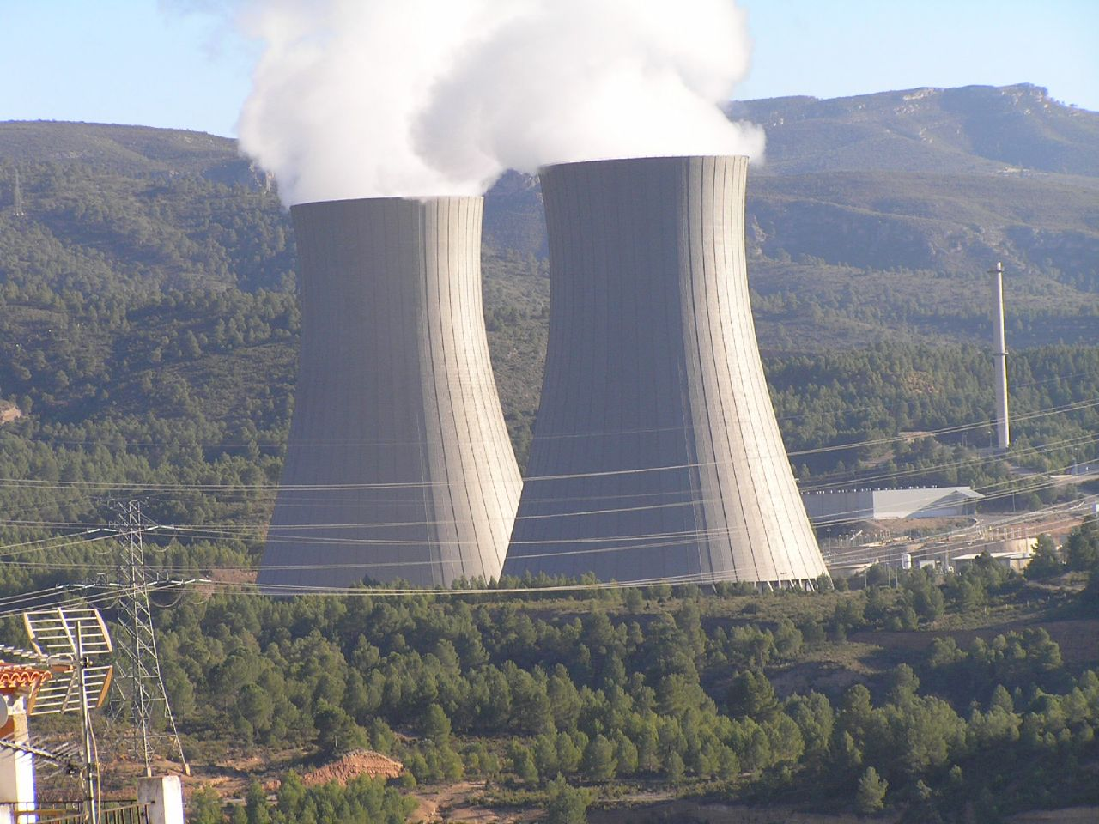

**Energy has many forms and all are measured by the amount of work they can do.**

**Forms of Energy**

**Thermal Energy:** Also known as heat, it is the total kinetic energy possessed by the individual particles that comprise an object.

**Internal Energy:** refers to the total potential energy and kinetic energy possessed by the particles that make up an object, but excludes the potential and kinetic energies of the system as a whole.

**Nuclear Energy:** the energy released by nuclear fission, the division of a heavy atomic nucleus into parts of comparable mass, or nuclear fusion, the combining of two light nuclei to form a heavier nucleus.

**Electromagnetic Energy:** the energy associated with electric or magnetic fields. Electromagnetic energy can take many forms such as visible light, microwaves, and radio waves.

**Potential Energy:** the energy possessed by an object **due to its position or condition**.

**Kinetic Energy:** the energy an object possesses **due to its motion**.

**Converting Energy**

**Photocell (Photovoltaic cell):** a device that converts light, a form of electromagnetic radiation, into electrical energy.

**Generator:** a device that converts mechanical energy into electrical energy by rotating a large coil of wire in a magnetic field.

**Motor:** a device that converts electrical energy into mechanical energy as a result of forces on a current-carrying conductor in a magnetic field.

**Battery:** a direct-current voltage source that converts chemical, thermal, nuclear, or solar energy into electrical energy.

**Gravitational Potential Energy**

If an object, originally at rest on Earth’s surface, is lifted to some height, work is done **against** the gravitational force. The work done in lifting the object to a height above Earth’s surface is equal to the object’s **gravitational potential energy**. The gain in potential energy is **independent of the path taken** by the object making gravitation a **conservative force**.

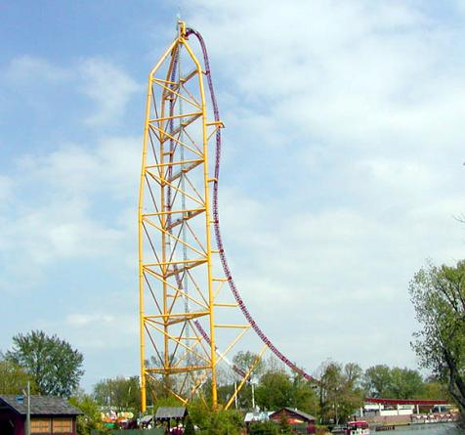

* If the object is **lifted up**, work is done **against** gravity.
* If the object **falls**, work is done **by** gravity.

**If the object falls, it loses potential energy which is converted into kinetic energy**. Therefore, the **object’s speed increases** during its fall. We will discuss later that this kinetic energy can do an amount of work **equal** to the loss in gravitational potential energy.

Technically, you already know the equal for gravitational potential energy. Since the work done lifting the object is transferred to the gravitational potential energy, then we must analyze **W=F.d**. Since the force is equal to the object’s weight, and the distance is the **change in height**, the change in gravitational potential energy is given by this equation:



Mass (m) is in **kg**, gravity (g) is in **m/s2** and change in height (Δh) is in **m**. Once again, all energy (including gravitational potential energy) is expressed in **Joules (J)** or **kg.m2/s2**.

**For Example:**

1.) Kristen carries her textbooks with a mass of 5-kg upstairs from the first floor to a new height of 3 meters. Determine the potential energy gained by the textbooks.

2.) Wile E Coyote holds a 200-kg anvil over a cliff that is 400 meters tall. Determine the potential energy of the anvil.



3.) An object is lifted from the floor to the top of a 0.92-meter high table. If the gain in potential energy is 100 J, determine the mass of the object.

4.) A 40-kg object gains 600 joules of potential energy. What is the object’s change in height?

5.) Joe uses 400 Newtons of force to raise an object to a height of 10 meters with help from a ladder. Determine the gain in potential energy of the object.

6.) Danielle throws a 7-kg shot-put straight up into the air to a height of 5 meters.

a.) Determine the gain in potential energy of the shot-put.

b.) As the shot-put increases its height, does the potential energy increase or decrease?

c.) As the shot-put increases its height, does the speed of the shot-put increase or decrease?

d.) Sketch a graph of ***PE vs. Height***.

7.) On Planet X, a 15-kg object is raised 20 meters which gains a potential energy of 1,000 J. Determine the acceleration due to gravity on Planet X.

**Kinetic Energy**

If work is done on an object and begins **moving**, the object has been giving **kinetic energy**. The energy an object possesses **due to its motion** is called **kinetic energy**. The formula for kinetic energy is:

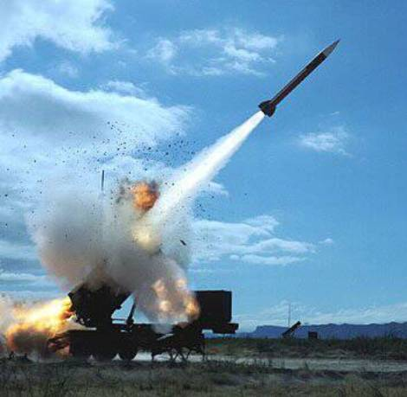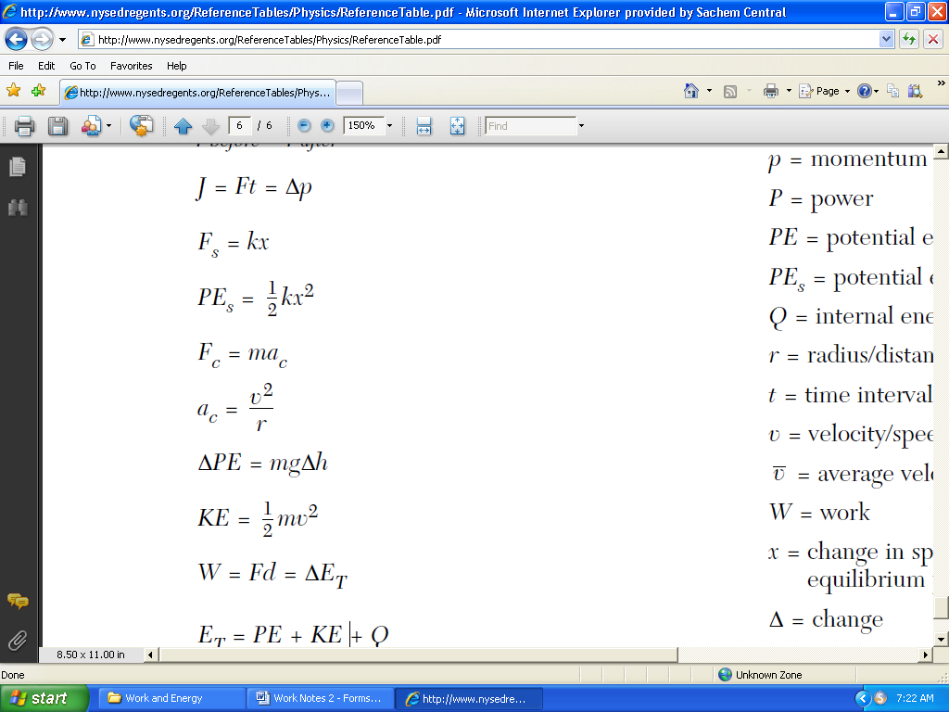

Mass is in **kg**, velocity is in **m/s.** Once again, all energy (including kinetic energy) is expressed in **Joules (J)** or **kg.m2/s2**.

Keep in mind that it is **velocity squared**. Therefore, the graph of KE vs. velocity would look like this:

**For Example:**

8.) Looking to pass another driver on the LIE, Diana doubles her velocity. What is the effect on her kinetic energy?

9.) Luke’s jet ski has a kinetic energy of 100,000 joules and a velocity of 20 m/s. If Luke triples his velocity, what is the new kinetic energy?

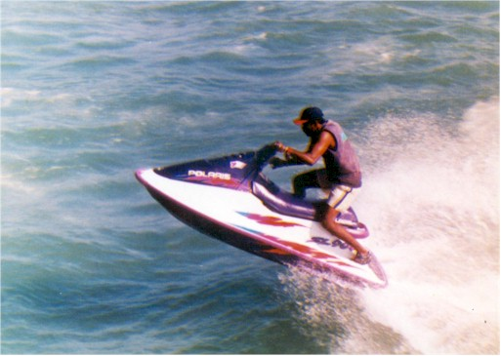

10.) A 3.0 kg cart is moving with a velocity of 10 m/s. Determine the cart’s kinetic energy.

11.) A 4,000 kg truck is moving with a velocity of 20 m/s. Determine the truck’s kinetic energy.

12.) A rollercoaster gains a kinetic energy of 300,000 J. If the total mass of the rollercoaster is 3,000 kg, determine the velocity of the rollercoaster.

13.) A “joule” thief takes off at a velocity of 8 m/s and has a kinetic energy of 2,200 Joules. Determine the mass of the bank robber.

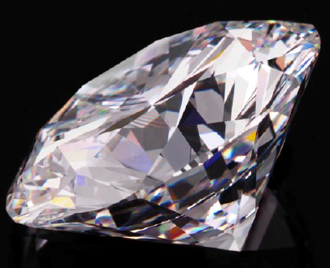

14.) Amanda uses 500 Newtons of force to push a massive 20-kg pumpkin a distance of 10 meters.

1. What is the work done on the pumpkin?

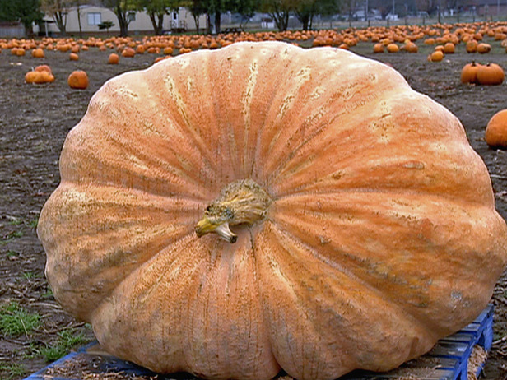

1. How much kinetic energy is gained by the pumpkin?
2. If the pumpkin starts from rest, what is the new speed of the pumpkin?
3. If Amanda has a power output of 200 W, how much time did it take her to move the pumpkin?

15.) Chris returns to the top of the school building with his water balloons. If the height of the school is 20 meters, and the mass of a water balloon is 0.65 kg:

a.) Determine the potential energy of the water balloon.

b.) If all of the water balloon’s potential energy is converted into kinetic energy, determine the kinetic energy of balloon right before it hits the ground.

c.) Determine the velocity of the water balloon before it hits the ground.