**Chapter 1- Kinematics Regents Physics**

**One-Dimensional Motion – Acceleration**

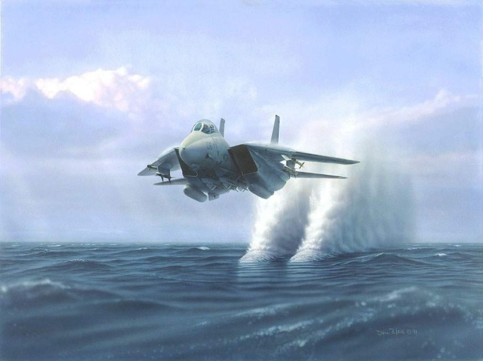The time rate of change of velocity is **acceleration**. Acceleration is a **vector** quantity and is defined as the **change of velocity per unit of time**. The equation is:

Since velocity’s units are meters per seconds, and time’s units are seconds, acceleration’s units are meters per seconds squared or **m/s2**.

The symbol “ simply means “change in”. This requires you to subtract the initial velocity from the final velocity. Therefore:

*vf - vi*

**Quick Example:**

1. A car increases its velocity from 20 m/s to 45 m/s. What is its change in velocity?

During the course of the year, we will only be working with **constant acceleration.** With constant acceleration, we may also find average velocity “v” to be equal to:

**V =**

**Acceleration Examples:**

1. A golf ball starts from rest. A golfer hits the ball and it travels 80 m/s in 5 seconds. Determine the **acceleration** of the ball.
2. A football is thrown 10 m/s and is caught and brought to **rest** in 4 seconds. Determine the acceleration of the ball. (Be careful with the change in velocity!)
3. A paper airplane has an acceleration of 5 m/s2. If it is thrown from rest, how fast will it be going in 3 seconds?
4. A truck’s change in velocity is 15 m/s. If its acceleration is 3 m/s2, how long did it take the truck to accelerate to this velocity?