**Name:________________________________ Regents Physics**

**Chapter 8- Work and Energy**

**Work and Power**



**Energy** is the ability to do work. Energy is a **scalar** quantity. When work is done on or by a system, the total energy of the system is changed.

**Work**

**Work** is the **transfer of energy** to an object when the object moves due to the application of a force. Work is a **scalar** quantity. The amount of work done, **W**, is equal to the product of the force, **F**, along the direction of the displacement, **d**. The work done on the object produces a **change in the object’s total energy, ΔEt.**

**W = Fd = ΔEt**

Since force is in **Newtons** and displacement is in **meters**, all work and energy can be expressed in Newton-meters or **joules (J).** Realize that a **joule** is also equal to **kg.m2/s2.**

The **joule (J)** is a derived unit equal to the work done on an object when a force of one Newton produces a displacement of one meter. When a force is applied to a mass, but the mass does not move, **no work is done**. The object **must move in order for there to be work!!!**

**Note: You must find the component of the force that is in the same direction as the motion of the object!!! In Regents, this is usually the x-component (horizontal).**

**For Example:**

1. Zach pushes a 200-kg bull to the right with a force of 500 Newtons. If Zach manages to push the bull a displacement of 0.4 meters:
   * 1. Determine the work done by Zach on the bull.



* + 1. What is the change in energy of the bull?

1. Kraig pulls a box to the right at an angle of 40 degrees to the horizontal with a force of 30 Newtons. If Kraig pulls the box a distance of 20 meters, determine the work done by Kraig. **(Remember: find the component of the force in the direction of motion).**
2. If Brooke does 400 joules of work to push a bookcase 10 meters a cross a room, how much force did she apply to the bookcase?

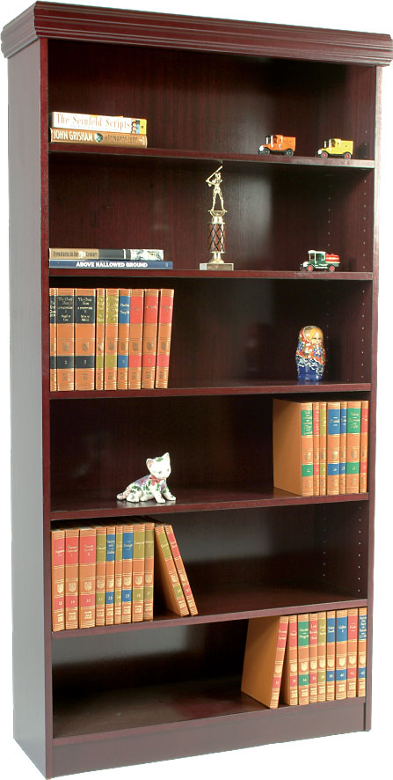

1. Liam uses 100 joules of work and a force of 20 Newtons to push a physics textbook across the lab table. How far will the textbook travel?
2. Courtney accelerates her 2,000-kg car at a rate of 10 m/s2. If Courtney accelerates for a displacement of 1,000 meters, how much work is done by the car?

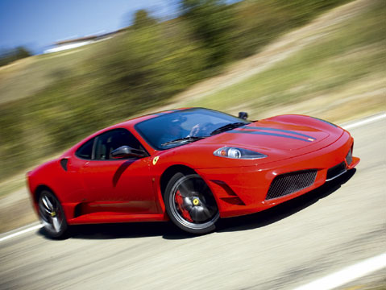

1. Nick raises a 4-kg mass vertically 0.05 meters above his head. Determine the work done on the mass.

**Power**

**Power** is simply the **rate at which work is done**. Power is a **scalar quantity**. Recall that the “rate” simply means dividing the variable by time. Therefore, power is found using:

However, we also know that **W=Fd** and that **.** Therefore, the above equation may also be written as follows:

One joule of work done per second equals one **watt (W)** which is the **SI** derived unit for power.

**1 W = 1 J/s = 1 kg.m2/s3**

Since power is **inversely proportional to time**, the less time required to do a given amount of work, the greater the power developed.

**For Example:**

**7.)** It requires 1,000 J of work for Celeste to push a couch to the other side of her room. If Celeste completes this task in 600 seconds, determine the power used by Celeste.

**8.)** Serap uses 200 Newtons of force to lift a brick a distance of 4 meters. If it takes Serap 20 seconds to complete this task, determine the amount of power used.

**9.)** A car’s engine provides a force of 2,000 Newtons which moves the car at an average velocity of 40 m/s. Determine the power developed by the engine.

**10.)** A truck uses 20,000 Watts of power to tow a trailer a distance of 2,000 meters in a time of 10 minutes. Determine the force used to pull the trailer.