Name ___________________ 11/18/08

**Science Test 🡪 Friday 11/21**

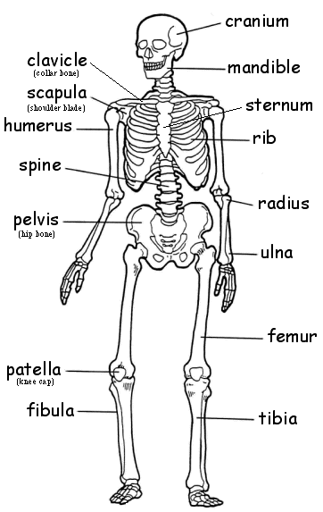

(skull)



Word Bank

skull (cranium) vertebrae (spine) clavicle scapula

ribs humerus tibia fibula

radius ulna sternum femur pelvis (hip bones) mandible

* **What are the main “jobs” (functions) of the Skeletal System?**
  + **___________________________________________**
  + **___________________________________________**
  + **___________________________________________**
  + **___________________________________________**
  + **___________________________________________**
* **Why are our bones so strong, flexible, and lightweight?**
  + Their _____________________
    - Spongy Bone = _____________________________
    - Compact Bone = ____________________________
  + They are made up of HARD minerals like _____________
* **What are the two different parts of our Skeletal System?**

|  |  |
| --- | --- |
| **Axial** | **Appendicular** |
| [Axial skeleton diagram](http://www.wpclipart.com/medical/bones/Axial_skeleton_diagram.png) | [Appendicular skeleton diagram](http://www.wpclipart.com/medical/bones/Appendicular_skeleton_diagram.png) |
|  |  |

* **In the chart below, fill out information on the other parts of our Skeletal System.**

|  |  |  |
| --- | --- | --- |
| Tendon | http://rds.yahoo.com/_ylt=A0WTb_0b0CJJ9FgA55qjzbkF/SIG=146gj63fb/EXP=1227104667/**http%3A/www.eorthopod.com/images/ContentImages/knee/knee_acl_patellar_tendon/knee_acl_patellar_tendon_anatomy03.jpg |  |
| Ligament | http://rds.yahoo.com/_ylt=A0WTbx9n0CJJPjsAcqWjzbkF/SIG=12vifpeqt/EXP=1227104743/**http%3A/www.sportsinjuryclinic.net/gallery/knee/lateral_ligament_rupture.jpg |  |
| Joint | http://rds.yahoo.com/_ylt=A0WTb_kS0SJJ0FQBqM2jzbkF/SIG=12m9j3p8b/EXP=1227104914/**http%3A/www.itl.nist.gov/iaui/ovrt/projects/vrml/h-anim/joint1C.gifhttp://rds.yahoo.com/_ylt=A0WTb_jp0CJJ9wUAtE.jzbkF/SIG=12krsovf2/EXP=1227104873/**http%3A/medimages.healthopedia.com/large/joint-x-ray-of-elbow.jpg |  |
| Cartilage | http://rds.yahoo.com/_ylt=A0WTb_lb0SJJfVcBlHyjzbkF/SIG=12url2tp5/EXP=1227104987/**http%3A/www.allaboutarthritis.com/image/stock_image/ankle_cartilage_MMG.jpg |  |

* **What would happen if you wear your cartilage away?**

|  |  |
| --- | --- |
| **What happens if it is worn away?** | **Two activities that wear it away** |
|  |  |

* **What is the difference between VOLUNTARY and INVOLUNTARY muscle?**

|  |  |
| --- | --- |
| Voluntary | Involuntary |
| Ex. | Ex. |

* **What are the three types of muscle?**

|  |  |  |
| --- | --- | --- |
| Skeletal | Cardiac | Smooth |
|  |  |  |

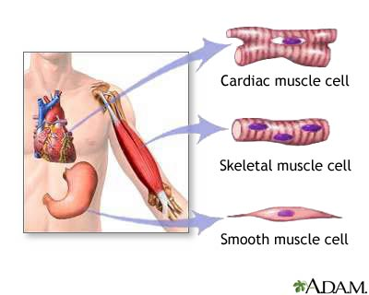

* **What would happen if your smooth muscle had a disease that caused it to be paralyzed (can’t move)?**

**________________________________________________________________________________________________________________________________________________________________________________________________________________________________________________________________________________________________________________________________________________________________________________________________________**