Math 7 Name____________

Period____ Date_______

**Review: Fractions**

**Perform the indicated operation. Write each answer in simplest form. You MUST SHOW ALL WORK for full credit! [4 pts. each]**

1. 2. ÷ = __________

+

3. ∙ = _______ 4. ÷ = _________

5. 6. 8 ÷ 4 = ________

-

_______

7. ● = ______

8. =______

**Solve:**

9. Zain can harvest acres of pumpkins in 1 day. How many acres of pumpkins can he harvest in days? ________

10. A Social Studies textbook is of an inch thick. How many of these books will fit on a shelf that is 48 inches wide? _________

11. Greg and James own neighboring pumpkin patches. Greg harvested acres of pumpkins on Sunday and James acres. How many more acres did Greg harvest than James?

_______________

12. Yesterday, Colin went through 8 bottles of Gatorade on Monday. If he drinks as much Gatorade on Tuesday, how many bottles of Gatorade did he drink on Tuesday? _________________

13. Nick earns $8.50 per hour working as a cashier. On Friday he spent hours stocking shelves, hours working the register, and hours cleaning the store. What were Nick’s earnings?

**[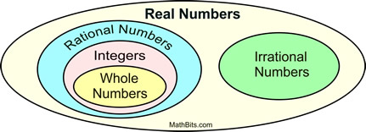](http://www.google.com/url?sa=i&rct=j&q=&esrc=s&source=images&cd=&cad=rja&uact=8&ved=0CAcQjRxqFQoTCIfc0ajIsMgCFYePPgodfhgGrA&url=http://mathbitsnotebook.com/Algebra1/RatIrratNumbers/RNRatIrrat.html&psig=AFQjCNH54-KjwxtbHx6X-Qr8zlpAa_8pmw&ust=1444314231126057)Match the following number systems with the correct set of numbers:**

**Give 3 examples of the following:**

Whole numbers __________________________________

Rational _______________________________________

Natural________________________________________

Integers _______________________________________

Irrational ______________________________________