Name:

1. One important impact of the Mongol expansion across Asia and Europe was the
   * 1. increased authority of the Kievan princes
     2. rise in trade along the Silk Roads
     3. introduction of Hinduism into Chinese culture
     4. maritime exploration of the Arabian seacoast
2. What was a direct result of the Black Death in Europe?
   * 1. The rate of urbanization increased.
     2. A shortage of workers developed.
     3. Food crops had to be imported from the Americas.
     4. German states dominated trade in the eastern Mediterranean.
3. In The Prince, Niccolò Machiavelli was most concerned with
   * 1. the use of political power
     2. the expansion of church authority
     3. government regulation of the economy
     4. equality and justice for all
4. • The world view shifted from other-worldly to secular.

• Greek and Roman ideas were revived.

• Improvements were made to the printing press.

Which occurrence is most closely associated with these aspects of the Renaissance?

* + 1. Gothic cathedrals became the focal point of town activities.
    2. Charlemagne was crowned Holy Roman Emperor by the Pope.
    3. Galileo Galilei published information about a heliocentric universe.
    4. Emperors used the Twelve Tables to bring about Pax Romana.

1. Which situation was an immediate cause for the collapse of the Aztec civilization?
   * 1. disruption of overseas trade networks
     2. conquest by foreigners
     3. a series of crop failures
     4. a lack of military training
2. Why is the year 1492 considered a turning point in history?
   * 1. The Spanish established an exchange between Europe and the Americas.
     2. The Ming dynasty launched expeditions to the east coast of Africa.
     3. Muslim Arab armies succeeded in conquering Egypt and Syria.
     4. The British established control over new territories in India.
3. In the 1500s, European attempts to establish colonies in Africa were hindered by
   * 1. the abolition of the slave trade
     2. the cooperative efforts of Christian and Islamic missionaries
     3. a variety of geographic obstacles in Africa
     4. a widespread unified resistance by African tribal leaders
4. Which idea is most closely associated with the economic concept of mercantilism?
   * 1. Colonies exist to provide raw materials and markets for a colonial power.
     2. Wealth and power are based on land exchanged between nobles.
     3. Goods and services are traded without government interference.
     4. Property is owned collectively and administered by the state.
5. One way in which the reigns of Peter the Great and Catherine the Great are similar is that both leaders
   * 1. promoted the emancipation of serfs
     2. strengthened the role of the Duma and centralized royal power
     3. shared their power with the Russian Orthodox Church
     4. pursued a policy of westernization and expansion
6. Which institution became stronger and limited the monarchy in order to end absolutism in England?

(1) banks (3) universities

(2) Parliament (4) Anglican Church

1. During the Renaissance, humanist philosophers emphasized the importance of
   * 1. individualism
     2. absolutism
     3. religious salvation
     4. technological advancements
2. Which statement about the Protestant Reformation is an opinion rather than a fact?
   * 1. German princes revolted against the Holy Roman Emperor.
     2. Membership in the Catholic Church declined in northern Europe.
     3. European religious unity was disrupted by the newly established religions.
     4. Henry VIII led a stronger religious reform movement than Martin Luther did.
3. The location of the Ottoman Empire had an impact on the
   * 1. trade between Europe and Asia
     2. conquest of Spain by the Muslims
     3. spread of Buddhism into Southeast Asia
     4. decline in the Atlantic slave trade
4. The rule of Akbar the Great is important because he
   * 1. admired legalism and emphasized oppression
     2. recognized natural laws and supported democracy
     3. accepted diversity and practiced religious toleration
     4. supported equality and outlawed the caste system
5. Europeans considered mercantilism a successful policy because it
   * 1. encouraged self-sufficiency in less developed nations
     2. led to alliances with Asian countries
     3. protected traditional social practices
     4. created wealth for the colonial powers
6. One similarity between the Magna Carta and the English Bill of Rights is that both documents
   * 1. set up a two-party political system
     2. placed limits on the power of the monarch
     3. established the right to inherit the throne
     4. guaranteed equal rights for all citizens
7. Which areas did the Mongols conquer and incorporate into their empire?
   * 1. China, Russia, and Iran
     2. Axum, Zimbabwe, and West Africa
     3. Spain, France, and Egypt
     4. Japan, India, and eastern Europe
8. Which factor contributed to Mali becoming a wealthy kingdom?
   * 1. enforcement of mercantilist policies
     2. alliances with the Hanseatic League
     3. control of Mediterranean trade routes
     4. dominance of the gold and salt trade

*Base your answers to questions 19 and 20 on the speakers’ statements below and on your knowledge of social studies.*

**Speaker A:** The chief problem with the Roman Catholic Church is the practice of selling indulgences. The only way for Christians to receive salvation is through faith alone.

**Speaker B:** If Christians want to be saved, they should perform good deeds and ask for forgiveness of sins. The granting of indulgences allows Christians to be excused for their sins.

**Speaker C**: It is true that the Bible, and not members of the clergy, is the ultimate source of religious truth. However, God has already decided who will be saved and who will not.

**Speaker D:** Since the Pope does not agree with my position, I have decided to separate from the Roman Catholic Church. I am now not only the head of England but also of the Anglican Church.

1. Which speaker most closely reflects the ideas of Martin Luther?

(1) A (2) B (3) C (4) D

1. Which speaker best supports the idea of predestination taught by John Calvin?

1) A (2) B (3) C (4) D

1. In the late 1400s and early 1500s, what was a major reason for the European voyages of exploration?
   * 1. introduction of Enlightenment ideas
     2. desire to control Constantinople
     3. rapid industrialization
     4. need for alternate trade routes
2. A study of the achievements of pre-Columbian Mesoamerican cultures would show that they
   * 1. sustained dense populations through intensive agriculture
     2. engaged in an extensive exploration of the Pacific Ocean
     3. built vehicles with wheels to transport goods
     4. developed rice paper and wood-block printing
3. An economic reason for the institution of serfdom was to maintain
   * 1. an educated citizenry
     2. a stable workforce
     3. overseas trade
     4. religious uniformity
4. One long-term effect of the Crusades was the
   * 1. development of Pax Mongolia
     2. fall of the Ming dynasty
     3. control of Jerusalem by Europeans
     4. growth of trade and towns in western Europe
5. One way Japanese feudalism during the Tokugawa shogunate was different from European feudalism is that during this period of Japanese feudalism
   * 1. political power was more centralized
     2. foreign missionaries were welcomed
     3. emperors were overthrown in coups d’état
     4. most wealthy merchants were able to attain high social status
6. The kingdoms of Ghana, Mali, and Songhai prospered primarily due to their
   * 1. exchanges with Indian ports
     2. direct access to the Arabian Sea
     3. control of trade routes
     4. abundance of diamonds
7. How did the Commercial Revolution change economic practices in Europe?
   * 1. The manorial system was established.
     2. A capitalist economy was developed.
     3. The Church became a major economic power.
     4. Colonies were granted independence.
8. One impact Gutenberg’s printing press had on western Europe was
   * 1. the spread of Martin Luther’s ideas
     2. a decrease in the number of universities
     3. a decline in literacy
     4. the unification of the Holy Roman Empire
9. What was a result of the efforts of Prince Henry of Portugal, Christopher Columbus, and Ferdinand Magellan?
   * 1. The importance of Mediterranean trade routes was established.
     2. The modern concept of universal human rights was promoted.
     3. The European view of the physical world was transformed.
     4. An understanding of the benefits of cultural diversity was encouraged.
10. The Spanish encomienda system in the Americas resulted in
    * 1. the strengthening of indigenous cultures
      2. political independence for the colonies
      3. the exploitation of natives
      4. religious freedom for the majority of peasants
11. Which region’s colonial class structure included peninsulares, creoles, and mestizos?

(1) western Europe (3) East Asia

(2) sub-Saharan Africa (4) Latin America

1. One similarity in the policies of Louis XIV and of Suleiman the Magnificent is that both leaders
   * 1. expanded their empires in the Americas
     2. encouraged the growth of democracy
     3. increased the power of their central governments
     4. abolished the bureaucracy
2. One reason the Renaissance began in Italy was that Italian city-states
   * 1. defeated the Spanish Armada
     2. were unified as a nation under the Pope
     3. were unaffected by the Commercial Revolution
     4. dominated key Mediterranean trade routes
3. In The Prince, Machiavelli advises rulers to
   * 1. seek the approval of the people
     2. establish and maintain power
     3. promote openness in government
     4. learn and follow the commandments of the church
4. During the Ming dynasty, why did China enjoy a favorable balance of trade with Europe?
   * 1. The Ming dynasty imported numerous manufactured goods from Europe.
     2. China exported large quantities of opium to European traders.
     3. Chinese silk continued to be in high demand in Europe.
     4. The Ming dynasty paid tribute to European traders.
5. One way the Incas adapted their environment was by
   * 1. building a network of roads through the mountains
     2. growing rice as a major agricultural product
     3. establishing an encomienda system
     4. creating floating gardens

*Base your answers to questions 37 and 38 on the passage below and on your knowledge of social studies.*

. . . It recounts the life of the officials, the notaries, the deputies, the proprietors of Indian labour, the priests, the miners and the Spaniards who travel from post to post along the roads and rivers of Peru; the visitors, the judges, the Indian chiefs and their subjects, including the very poor.

In my work I have always tried to obtain the most truthful accounts, accepting those which seemed to be substantial and which were confirmed from various sources. I have only reported those facts which several people agreed upon as being true. . . .

* + - * Huamán Poma, Letter to a King: A Peruvian Chief’s Account of Life Under the Incas and Under Spanish Rule,E. P. Dutton

1. This author is describing the process he used in
   * 1. formulating a scientific theory from earlier experiments
     2. developing a historical account from primary sources
     3. comparing details of differing religions
     4. explaining the importance of obeying laws
2. According to this author, accounts used in making statements of fact must be

(1) brief (3) verified

(2) interesting (4) unbiased

*Base your answer to question 39 on the map below and on your knowledge of social studies.*

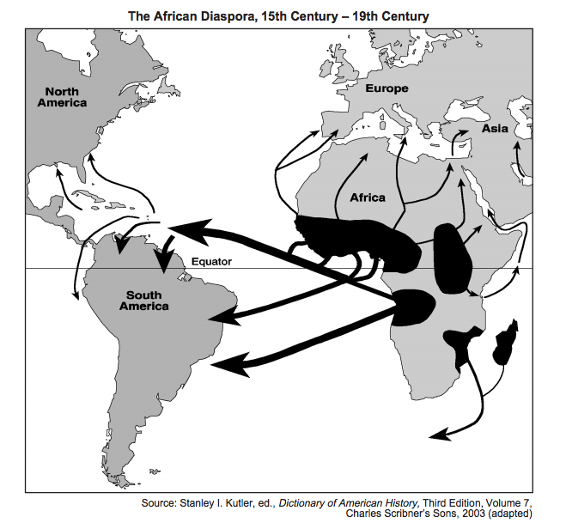

1. The arrows on this map, “The African Diaspora,” represent the
   * 1. development of trade routes in North Africa
     2. expansion of African kingdoms involved in the slave trade
     3. forced migration of African peoples from their homeland
     4. dependence by Africans on imports for economic development
2. Akbar the Great, Suleiman the Magnificent, and Louis XIV are all rulers associated with

(1) natural rights (3) religious toleration

(2) filial piety (4) absolutism

1. What was one ideal of Renaissance humanism?
   * 1. training as a knight and practicing chivalry
     2. obeying divine right monarchs and the church
     3. living apart from the world and taking monastic vows
     4. investigating areas of interest and fulfilling one’s potential
2. • Captured the city of Constantinople in 1453

• Benefited from rich trade along the Mediterranean Sea

• Ruled by Suleiman the Lawgiver

Which empire best fits these descriptions?

(1) Roman (3) Mongol

(2) Ottoman (4) Songhai

1. One way in which the Ming dynasty in the early 1400s and the Spanish monarchy in the late 1400s are similar is that both governments
   * 1. promoted religious diversity
     2. encouraged democratic reforms
     3. emphasized equal rights for women
     4. supported the expansion of overseas trade

*Base your answer to question 44 on the diagram below and on your knowledge of social studies.*

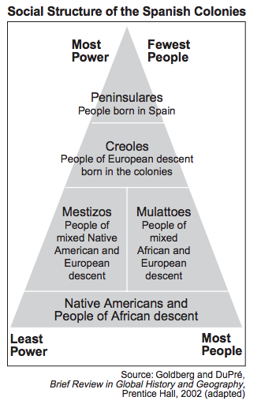

1. Which conclusion about Spanish colonialism in the Americas can be drawn from this diagram?
   * 1. The fewest people in the population had the greatest power.
     2. Africans and Native Americans were politically powerful.
     3. The peninsulares made up the majority of the population.
     4. Mestizos and mulattoes controlled the most land in the colonies
2. What was one effect of the Columbian exchange on European society?
   * 1. Migration to the Americas declined.
     2. Horses were acquired for the first time.
     3. The population increased with the introduction of new foods.
     4. The Christian Church was divided into Roman Catholic and Orthodox
3. By closing Japanese harbors to most foreigners in the 1600s, the Tokugawa shogunate attempted to
   * 1. protect Japan from European influence
     2. increase Japanese agricultural production
     3. eliminate Japan’s influence on Southeast Asia
     4. destroy traditional Japanese culture
4. The Ottomans were a strong trading empire through the mid-1600s because they
   * 1. controlled access to the eastern Mediterranean Sea
     2. had the most powerful navy in the world
     3. dominated West African caravan routes
     4. conquered most of Asia
5. One way in which the Aztec and Inca civilizations are similar is that they both
   * 1. defeated the Spanish conquistadors
     2. developed advanced architectural techniques
     3. lacked strong central governments
     4. settled primarily in river valleys
6. One effect of the encomienda system in Latin America was that it
   * 1. eliminated the use of guilds
     2. promoted isolationism
     3. exploited indigenous peoples
     4. reduced Spanish influence
7. In England, the key principles of the Magna Carta were fundamental to the development and growth of

(1) democracy (3) absolutism

(2) theocracy (4) communism

1. The encomienda system, the latifundia form of land ownership, and the office of viceroy are all closely associated with
   * 1. Spanish rule in Latin America
     2. pre-Columbian practices of Native Americans
     3. attempts to halt the drug trade in South America
     4. reduction of trade barriers in the Western Hemisphere